Philosophy and vision.

OVERVIEW

Playing style

Formation: 4/3/2/1 adaptable
Style: compact and disciplined in defence, with speed and aggression winning the ball back and the ability to hurt opposition as quickly as possible before they can reorganise. The biggest emphasis is on winning and any advantage available will be used to achieve a winning result.

Defending
I’d like my teams to play a style of football, that is defensively organised, hard to break down and has compactness whilst defending against all goal scoring threats from play in front, behind and either side of my defensive line.

My team will strive to defend from the front 1/3 and be proactive in effectively pressing the opposition in their weakest position, deny them time and space to use their bp effectively.

Depending on our own strengths vs oppositions, we will not be too proud to hold a deeper defensive block to keep compactness and win bp in effective areas which will allow us to forge dangerous counter attacks.

Attacking

In attack we will have effective possession, consisting of playing forward when we can, playing sideways if we have to and playing back if we really must, in turn leading to greater consistency of forward passing which break opposition lines and enables a higher success rate in receiving more passes in dangerous positions in and around our A1/3.

Position will be more important than possession, meaning we won't keep BP for the sake of keeping BP, but we will strive to play into dangerous goal scoring positions as quickly and as often as possible, encouraging aggressive, direct and fluid attacking play in our A1/3.

When the opportunity presents itself in the ideal situation, players will be encouraged to break lines with a dribble, rwb or combination, in turn creating overloads in all areas of the field. In Wide areas fullbacks are encouraged to first ensure their defence duties are secure but secondary, have freedom to link up with wingers or explore empty space in front of them.

All attacking play will be carried out in an intelligent fashion meaning defensive positions will always be in mind, in an event that an attack should break down.

Set pieces

Set pieces will be diligently worked on in training in both attack and defence. Attacking set pieces will vary from creative short executions, to a more direct style. Defending set pieces will always be with the highest concentration and commitment, with the awareness to react to opposition practiced routines and the aggression and courage to deal with direct ariel threats.

FORMATION AND PLAYING STYLE
Playing Style:
- Attacking with width and aggressive forward play when opposition is disorganised or to disorganise opposition defence.
- Fast tempo in BP, Break up play in BPO
- Attempt to defend in a 1/4/5/1 when possible and hit opposition on counter attack
- Press in opposition D1/3 and if BP not won in 5 seconds, drop and defend M1/3 just above halfway line.
It should be noted that formations can quickly change depending on player positioning during any main moment.
My 1/4/3/2/1 is basically a 1/4/3/3 with the ability to have the wide players drop back to make a 1/4/5/1 if needed.
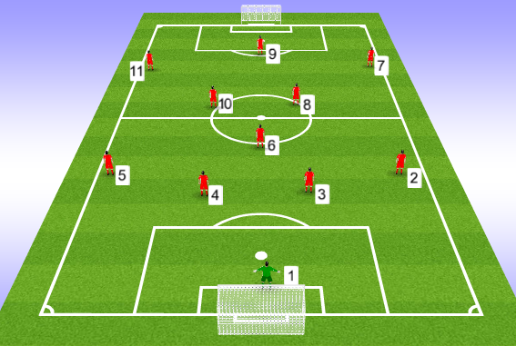
#1 takes ownership of his area and commands the backline in relation of the ball. He is responsible for his own positioning in reference to a high or low defensive line and will be ready to sweep up and danger behind the defence when needed.
#2/5 – with #7/11 having licence to support the #9 in attack, our 2/5 can take it in turns to roam up and down the wing and to make an extra man in midfield or to linkup in attacking combinations down the wing. Intelligence must be upheld so defence isn’t short on numbers vs an opposition counter attack.
#3/4 - Control the back line in defence and in attacking phase 3 or 4 looks to step into midfield and create overloads when possible. They are encouraged to play forward when possible even if it’s a more direct pass.

#6 – this is the player who’s main duty is to shield the defensive line. They are seldom expected to push into attack and by only having one DM, there is no confusion with who has the defending duties. He is the player to drop into the defensive line when needed and is also responsible for keeping the ball moving through the 3rds. Forward passing and killer passes are encouraged as if BP is lost, he is in a great position to defend.
#7/11 – these players need the ability to get up and down the pitch like wingbacks. They have the freedom to play as wingers and support the #9, or can easily adopt a more defensive shape and hold in their midfield positions. They are encourage to change positions with #9 during the match and also to fill into the #2/5 position when needed. When in BP they are to attack with aggression and be positive in 1v1 situations.
#8/10 – These are to rotate depending on positioning and situation in each main moment. One must support our #6 whilst the other plays a more advanced role supporting our #9. They are to look to receive between the lines and face forward in BP as much as possible. Ball distribution should be linking up with 7/11/9 and also look to hit balls in behind opposition 2/5.
#9 – Needs to be able to hold up and link play but also the ability to get in behind the defence. It is encouraged for him to drop deep to receive freeing up our 7/11 to attack spaces in behind. He has freedom to move into wide areas in our A1/3 so our wide players can then attack centrally in vacant space.

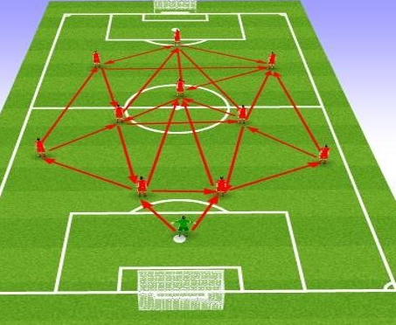
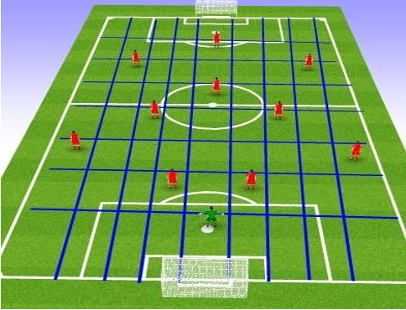
Our formation and shape allows us to keep passing lanes occupied in turn, giving us passing options in all areas of the pitch in relation to ball positioning. Players are encouraged to fill a position after player movement has emptied a position.

BALL POSSESSION
We will attempt to play out from the back when possible, but not be too proud and push it through when it’s not the right time – in which case we will just hit direct to our wide areas.
When our GK has BP;
Team Task- open pitch as wide as possible to create space for off ball movement.
GK – place ball in centrally
2/5 - push high and wide beyond opp 9/10
3/4 - split either side of penalty box
6/8/10 – set in triangle, be ready to rotate
7/11 – move inside centrally if 2/5 are high enough
9 – Be ready to be main target man or drop to allow 7/11 to advance

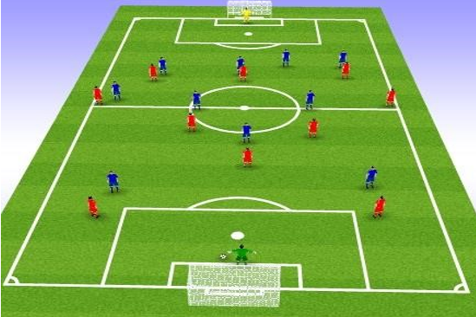

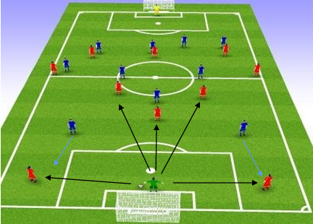
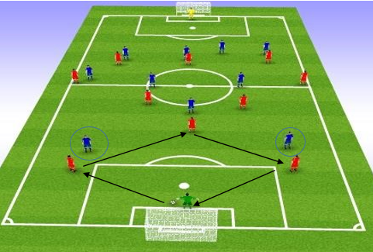
If our 3/4 are man marked, drop deeper to try and drag markers down. GK has choice to play through 3/4 if not marked, or to 6/8/10 if our 3/4 are marked.
Cues:
GK – pass to back foot so receiving player can play forward. If not, no risk go long.
3/4 – First touch to control facing forward, pass into 6/8/10 or to play back to GK.
6/8/10 – If ¾ drop deep, give movement to free space and receive beyond opp 9/10.
6/8/10 – if GK receives or 3/4 facing forward, initiate movement to create space to receive.
Attempt to create 4v2.
Player tasks:
GK – Start play through 3/4/6 positions, if not can you hit 7/11 or if need to, look direct for #9.
3/4 – look to receive and play into M1/3,if not, can you use the GK to change direction of attack?
6/8/10 – Be ready to receive from GK or 3/4, if marked tight can you rotate to free up a receiving opportunity? Attempt to receive in a position to face forward.
2/5 – One choose to drop and support build up play or can you rotate with 6/8/10 to create more space in M1/3?
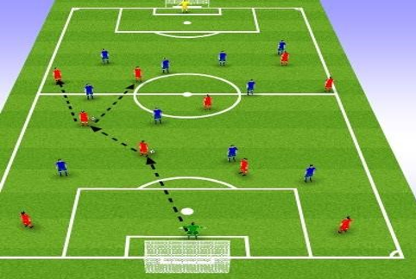
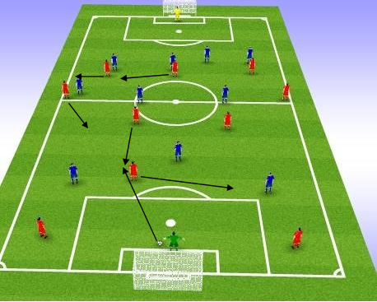
9
111
10
10
5
8
5
8
6
6

If 6 or 8 are able to receive and face forward, lets try and get our 2/5 in a position to support the buildup play, with our7/11 and 9 moving into position to keep at least two forward passing options for the ball carrier.
If #8/6 can receive facing forward;
#5 – drop inside towards ball and free up space. If marked tightly can you move away and create space for #11 to receive? If #5 drops, #11 to be ready to give an extra passing option with width. #9 ready to give a second passing option to hold up play and play back, or turn to face forward.
When #6 position drops to receive, he will not receive but he will pull his marker away from center.
This is the cue for #8/10 to try and receive and play forward, with options to play to #6 or GK if needed.
If #6 movement has lost his marker he can receive and look to play forward, with #8 & 10 looking to keep a passing triangle option.

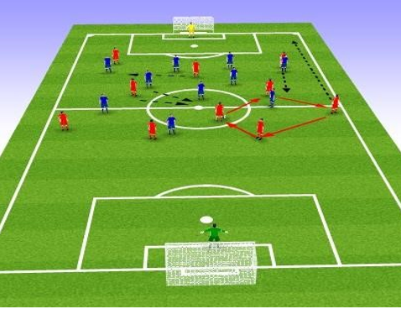
Build Up through the M1/3
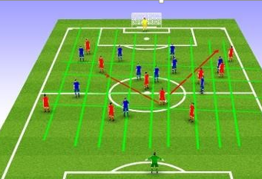
11
7
9
2
8
9
10
8
10
7
6
3
2
6

Player Cues:
Movement and actions as demonstrated in pictures to occur when #6 faces forward;
#8/10 – look to receive on turn or bounce back to 6. If 6 head is down then he is going long so ensure in good position to support 2nd ball.
#9 – drop away from opp 3/4 and in between opp 2/3. If no joy go back to start position.
7/11 – furthest forward to move into #9 position when he drops out, closest to ball to invert to free up wing space.
#2/5 – attacking fb with space in front to invade to make forward run giving #6 ball player option for direct pass.
Team Task – Attempt to create 3v1/4v1 situations in M1/3 with a view to receive and play forward.
GK - Take up positioning to defend against long balls.
3/4 – look to play forward when possible, break the lines with pass or rwb.
#6 position remain the link player to switch play if available.
8/10/9 – Ensure positioning is kept to give ball player as many forward passing options as possible. If marked closely can you rotate to free up space?
#7/11 – Attempt to free up space down the wings by coming inside whilst stretching the pitch as high as possible.
2/5 – Look to take advantage of space in front with forward runs. If no space in front, try to position yourself outside of the ball player to receive and play forward.

BALL POSSESSION OPPOSITION
I would like my team to defend high from the A1/3 in an attempt to win the ball back within 5 seconds. The trigger for our press is when the ball is played into their 2/5 position and if opposition 3/4 get on the ball, we should adopt a more defensive shape and limit their chances of breaking our lines.
Team Task – Attempt to create 4 man pressing trap in wide areas of opp D1/3.
#9 – cut off pass back to GK or the switch. If trap breaks down drop behind ball.
7/11 – Stop ball player playing forward down the flanks.
8/10 – Stop the ball player playing forward inside.
#6 – Deny ball player making forward passes between our two front pressing players.
#8,11, offer protection to defensive line. Counter ready.

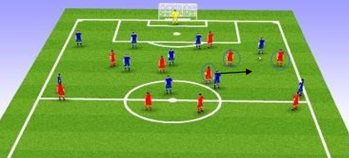
9
8
6
10
7

Cues: ** Pressing movement during ball travelling (being passed) to trigger position not before or after.
9 – Position between ball and GK with good distance to intercept pass across goal to opp #4.
10/8 – Press ball player from inside to wide.
7/11 – Press ball player from wide to inside.
6 – Block the passing lane between our front two pressers.

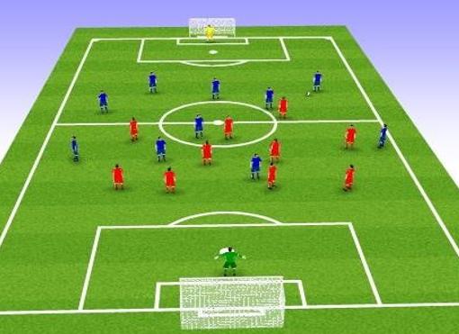
Team Task – If don’t win BP in A1/3 within 5 seconds get behind the ball. 1/4/5/1
#9 attempt to shift play into wide areas of M1/3 which will be our new pressing trigger.
Same pressing technique as before but no 5 second rule. Aggressive press until BP is won back and deny all forward passes through the middle.
GK – control the back line and communicate whilst setting good positioning to sweep and claim.

TRANSITIONS – BP to BPO
Recovering after our attack breaking down:
With our style of attacking having 7,11 support our 9, there will be times we get caught unorganized.
To regain shape we must concentrate on our distances between our defenders being between 6-8 yds.
#10 attempts to show play to one side whilst 8/6 support 10 and drop into to fill spaces in defence if needed.
7/11 on the opposite side of the ball should work hard to make recovery run and cover FB who has moved inwards to keep compactness.

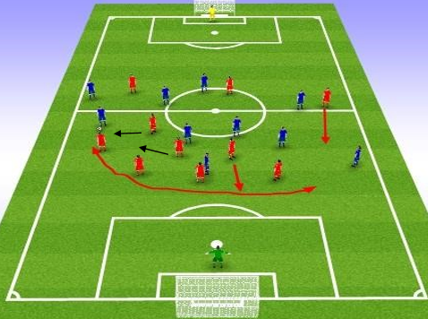

8
6
5
10
2
3
4

Player Tasks | Player Cues
2/5 attempt to close down wide threat quickly, choose to tackle/block/deny/delay. | Quickly out to ball player, body shape side on, attempt to push outside to allow time for shape recovery.
3/4 choose correct positioning to offer cover to pressing defender and balance to opposite FB position. | Drop behind ball pressing defender, with the other having central body shape so can see both outside positions and head checking.
6/8 decide the best movement to protect and secure defensive shape. Does ball player need pressing/defence need shielding or an extra defender needed in back line? | Closest player to 10 drop behind him with positioning screening defence and body shape to push out to press if needed. Furthest away from ball to drop into defensive line or if 7/11 has recovered, add an extra defensive screen between df and mf lines.
#10 – attempt to cut pitch in half and deny opp pass across/square. | Press ball player from central to wide ensuring body shape pushes play side or back. Pressing run should come in a round shape and not straight line.
7/11 – ball player side to be ready to support our counter attack. Non-ball side to attempt recovery run behind our 2/3 or decide if position between df and mf is better. | Recovery player to fill in any vacant 2/3 position and head check for opposition players getting in behind.
#9 – Be ready to cut off passes back into defence for recycle and ready for our counter attack. | Position between opp CB and FB to occupy both players. Ensure to stay in front of them to deny back pass attempts.
GK – Take up good positioning behind back line ready to command box but also to sweep if defence caught too high. | Consider distance from back line in relation to ball positioning and likelihood of dangerous shot happening with each opposition ball movement

TRANSITIONS – BPO to BP
On winning back BP our Team Task/main aim is to get the ball back into our A1/3 as quickly as possible which includes taking the least amount of passes as possible. This does mean however, that possession must be kept and not just hitting a long ball into our A1/3 with a hope that we get on the end of it. Attack should be constructive with short combination and supported by 5 players – 9,10,7,11(or either2/5 if 7/11 recovered), 6 or 8.
If 3,4, 6/8 carry the ball and continue to support the attack, a player must stay to ensure our defensive unit always consist of 4 defenders and a defensive midfielder to screen.
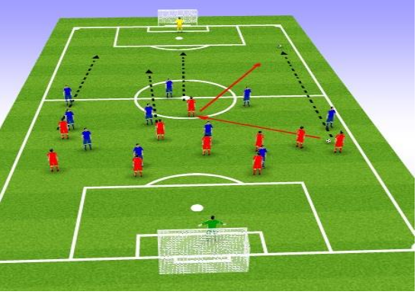
SET PIECES
** Note: Unlike previous diagram – set pieces are; red line = movement, black line = ball movement
Set Pieces
Attacking Corners:

The 3&3 split

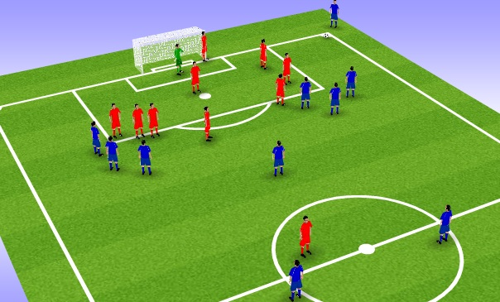
Set up:
Nobody inside the box, 3 at the back, 3 at front
Player outside box deeper to pick up 2ndball or depending on corner, to shoot
Short/deep/shot corners have their own signal
Plan:
Too often players fill the box and have no threat. The idea is to try and create effective 1v1 aerial battles or use individual skill with a short, 3v3. The 3 closest players pull defenders out. If not, short corner is played to shoot, keep possession, dribble into box or put in a cross
If no options with front players, ball is sent deep to back players with the best ball winner being furthest back to try and make a 1v1 and head ball to goal or back into mixer.
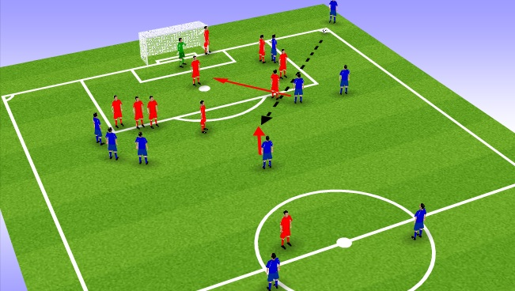
Setting for the shot for player on outside of box. Starting position of shooter should be deeper so not to alarm the DF.
The 3 players short are to make space for the pass through with at least 1going into the box to block the GK view.
2 of the 3 back post players attack the box and 1 drops deep ready to defend the counter attack.
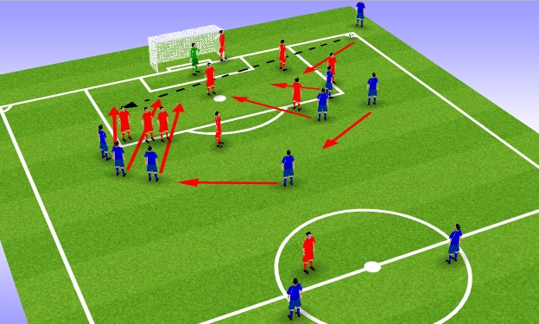
Deep corner, 1 player peels off to create 1v1 and the others attack the box accordingly. Players on front post support in the box and DMs position to defend any counter attack.
This is very effective if have 1 very strong ball winner. In the 1v1 header, even if lose then players are in position to pick up 2nd ball.
This corner has given lots of reward in the past but we had a strong ball winner at the back post who would win almost all headers. Even if this is not the case, 2nd ball winners can be positioned so that a lost header wasn’t necessarily a bad thing.

The 6 Yard Smash:

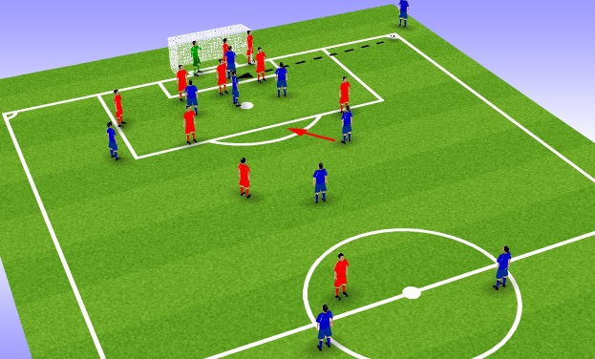
Set up:
In swingers needed
3 players positioned ready to attack 6 yd box. Delivery should be on 6 yd box so DF have no run up or it’s played behind them.
1 player should be on the GK.
1player around back post incase over hit.
Out of the 2 DMs, 1 stays outside box to break up any counter, the other goes into box to pick up and lost header 2nd ball.
If GK collects, player at back post must make recovery run to help DM.

Plan:
GK and 6 yd box is hammered and heavy pressure put into danger zone to make it difficult for DF to clear. This is useful if we are not strong in the air but we can still cause problems and unsettle a DF.
Players need to be aware of positions if need to defend the counter or pick up 2nd balls.

Free Kicks:

The Kingsman:
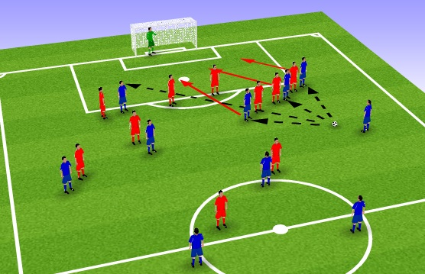
Set up:
Player placed in front/middle of wall and either side.
Best aerial ball winner placed at back post
Plan:
Using hand signals, free kick can be taken short to any player in wall. They can then play it back to taker or turn to dribble/shoot.
If the wall and DF are keeping things tight, players in wall should disrupt and kick is taken to player at back post. At the same time the players in the wall should spin off and support in the box.
If long ball is taken then players should be in place for 2nd ball win and to DF against the counter.

The Hole:
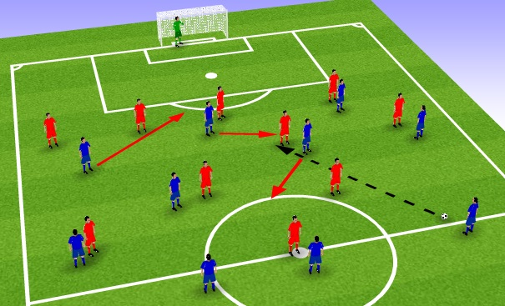
Set up:
Set in a 433 shape with width to try and stretch the pitch.
The move will be executed with 3 players making main movement

Below are the 3 steps of movement

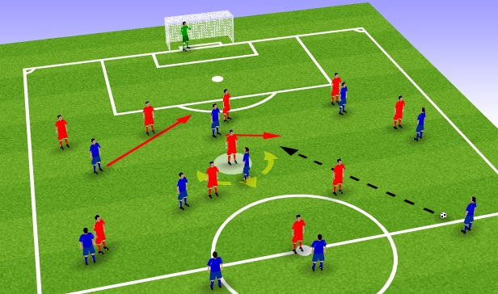
Player moves out of space and looks uninterested in the play, maybe even walk out of the space.
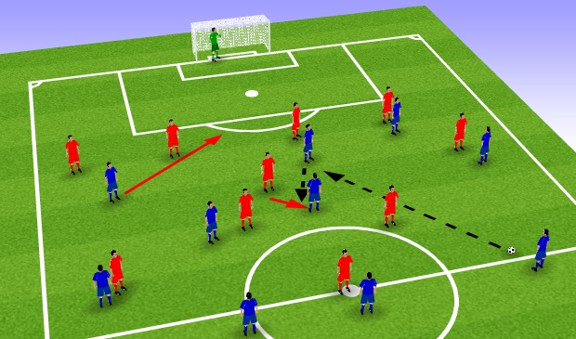
The trigger is then set for striker to run into vacant space and receive pass
At same time, the uninterested player has stepped back into play to receive from striker

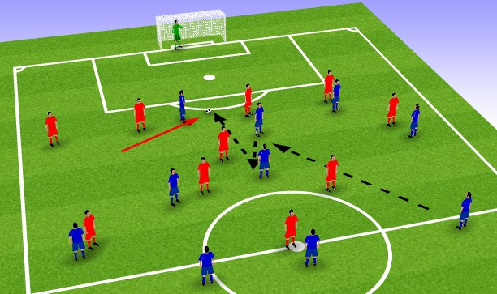
Wide player moves into hole left by striker and ball is played through.

Notes:
Defending team will more likely be defending more narrow but we must try create as many holes as possible.
1 touch play is needed and players must all respond together on the same trigger.
If DF don’t follow the striker on 1st pass, then striker can turn and attack.
MF player who looks ’uninterested’ needs to play the part well then snap into action.

The Switch:
Before kick is taken, arrowed plaers move in direction to create a sense of something is about to happen.
The central player pushes up to try and drag a player with him.
The wide player quickly drops and calls for the ball
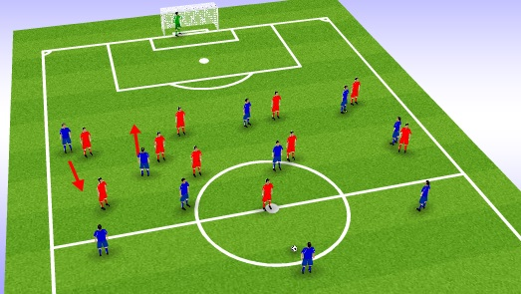

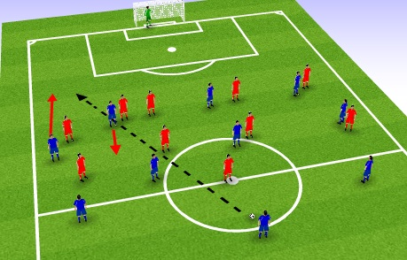
After the first movement above, the two players then quickly switch back and go into the opposite direction again.

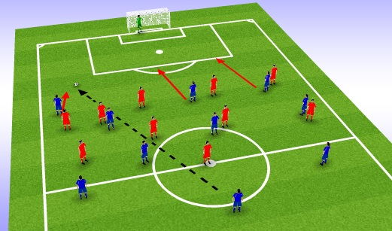
The DF has now been dragged slightly out of position and our wide player has space to run into.

Defending Set pieces
- Ability in air to mark Ability in air, after that marking = height for height
- Man Marking and zonal if players spare
- Awareness of short opposition routines
- GK decides how many players in wall
- Have player/s defending outside our box on corners to clear lines and start our counter.
- NB – defending positions can differ depending on opposition attacking positions

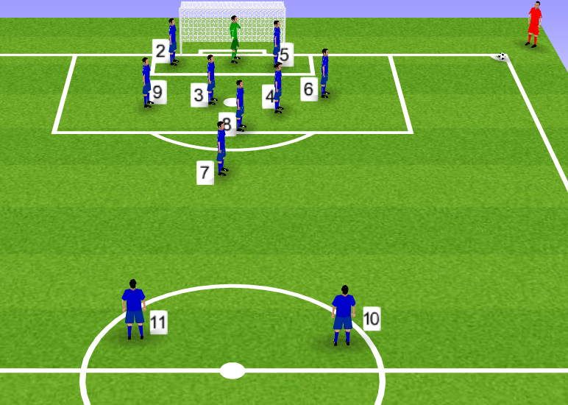
2/5 – front/back post areas. Free to attack their area. Front post assist in short corner if needed.
#6 is the bullet and attacks ball in zonal area. Only marks if needed.
9,3,4,7 (2 if needed) – Man Mark
7- mark player outside if needed, if not defend inside box.
10,11 stay high to ensure opposition leaves 3 defenders back or risk going 2v2
GK – control 6 yd box with violence and commanding, looking to set off fast counter attacks.

