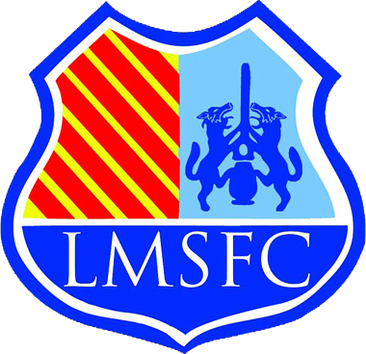
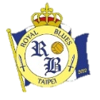
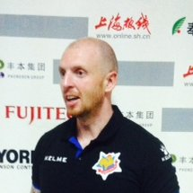
Head Coach / FWZ Rovers
Academy Manager / KAB Utd
1st Team Coach – Rovers FC
Academy Coach – Rovers FC

#

EXPERIENCE

Available for roles worldwide
Experience in Asia / Africa
Contact: mmm@gmail.com

JAMES SMITH

Qualifications
UEFA A Licence
English FA Youth Award
BA Degree in Coaching
LMA Management

Instructions to edit and send to your social media profiles
- Change each component of the image by clicking on the part you want to change, and input your own content.
- Add your own logos and photo by clicking on the image, and adding an image from your own files.
- When complete, cut the image using a cutting tool (snipping tool is free and easy to use).
- Cut around the completed image and safe as an image file
- Upload it to your social media from computer OR
- Email the image to yourself
- Download it and save to your photos on your mobile phone
- Upload it to your social media from your photo photos/images
NB. Save as PDF first or ensure that all the red correction marks are deleted from the image

