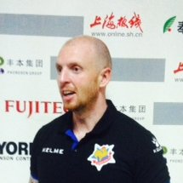

5 Years coaching experience in Asia

Experience as Academy Manager

Worked with 1st teams & Youths

Mobile:

Email:

Skype ID:

**Matt Ward**

**Coaching Experience**

**Players Coached**

**Opposition Coaches & Players Faced**

**Tahj Minniecon**

(Western Sydney Wdrs)

**Phil Younghusband**

(Chelsea)

**Davi Rodrigues de Jesus**

(Shanghai SIPG)

**Biro Biro**

(Fluminese)

Secured league wins against;

**Tianjin Quanjian**, coached by Fabio Cannavaro.

**Qingdao Huanghai,** coached by Jordi Vinyals (Former Barcelona B Coach).

**Wuhan Zall,** coached by Ciro Ferrara (Former Sampdoria and Juventus Coach).

**Alex Teixeira**, **Ramirez** (Ex-Chelsea), **Jo** (Brazil & Ex-Manchester City), **Nikica Jelavic** (Ex-West Ham), **Luis Fabiano** (Brazil & Sevilla).



**- Head Coach**

Ghana (Div 1)

Kotoku Royals

(2017)

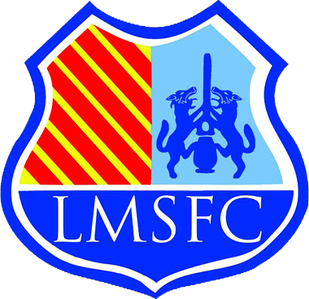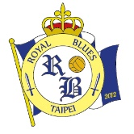Premier GlobalLeague Managers AssociationFootball Federation Australia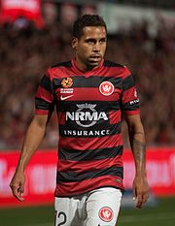Sports Management Worldwide

**- Culture of Excellence**

**(League Manager’s**

**Association)**

**- Diploma, Fitness Coaching**

**- Assistant Coach**

China League One Shanghai Shenxin F.C

(2016 – 2017)

- **Assistant Coach**

Philippines UFL (Top Tier)

Loyola Meralco Sparks F.C

(2015 - 2016)

**- BA (Hons) Management**

**- Honours in Sports Coaching**

**- A Licence**

**Simon McMenemy** – Head Coach of Indonesia National Team

**Louie Lancaster** – Head Coach of Chinese Taipei National Team

*“I played under Matt when he was coaching Loyola Sparks in the Philippines and he is the reason I started to enjoy my football again. Matt’s passion and knowledge of the game, helps to create a winning environment and achieves results on and off the field. Matt holds the most important strength as a coach, which is the ability to have players wanting to play for him. I fully trust Matt as a coach and a man, and fully expect him to achieve great things in his career, whilst having no hesitations in recommending him to any club”.*

**Tahj Minniecon; 2014 AFC Champions League Winner**

**References**

**About Me**

**- Head Coach**

Taiwan Premier (Top Tier)

Royal Blues Taipei

(2012 - 2015)

**- Community/Youth Coach**

England Southern League

Hereford United

(2008 - 2010)

Team disbanded 2012

I’m a coach with proven maturity and personality to succeed as an effective Assistant Coach. Along with my strong theoretical and practical skills, I have experience of winning a League Title; the 2nd Division in Taiwan which in turn, saw us qualify to the Top Division and being 3 points from an AFC Cup place on my exit in 2015. I’ve now coached in two top tier leagues in Asia, and also at Shanghai Shenxin who was in the Chinese Super- league in 2015. I was headhunted by Loyola Sparks and Shanghai Shenxin as Assistant Coach, allowing me to develop my coaching ability by leading a higher quality of player against better opposition. I’m a firm believer that the ‘person’ should be coached before the player and that results are formed by overall squad harmony and environment. My knowledge and experience in fitness and analysis allows me to create holistic training sessions and I have the skill to identify any needs for individual training programmes. As a previous P.E teacher and Academy Manager, I also have the ability to connect with the community and players at youth level, having worked with children from aged 3 – 12 years old.

**- Scouting Course**

**(International)**

**Education & Courses**