FFA Session Plan
Playing Group: Kotoku Royals | Session No: |  | 1 | Date: | 21 March 2017
Main Moment: | BP
Football Problem: When in possession of ball in M1/3 (middle third of pitch), the ball carrier (#6, #8) is losing possession due to limited passing options and tight playing areas. This in turn is setting up opposition counter attacks.
Objective: In this session I aim to improve my team’s ability to make forward runs off the ball, to create and exploit space in the M1/3 and A1/3.
Warm up / Passing Practice
Diagram:  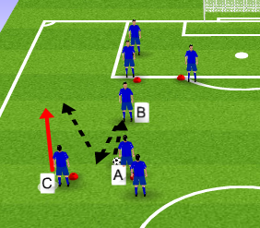  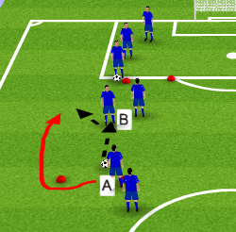 |  | Organisation/Explanation:  - 18 Players, 2 x 9  - 4 Markers per group  - 5 balls per group  - Specific area of field selected  A plays a one-two with B, C starts their run forward.  A Passes into the forward run of C.  C passes into the A of opposite group and sequence starts again.  C joins back of the opposite group.  Players follow the pass – A goes to position B after the pass to C. B goes to C. C joins opposite group.  B faces direction of play.  - Extra Ball is added and extra Player B in centre.  - 2 balls in play, 1 each group.  A now passes to B and makes a run around the marker and forward.  B turns and plays into path of A and sequence continues.  Bs stay in centre and rotate on coaches que.  ** Static and dynamic stretching done throughout  -Quality of touch important  -Quality of pass into forward runner important

Positioning Game:
Diagram:  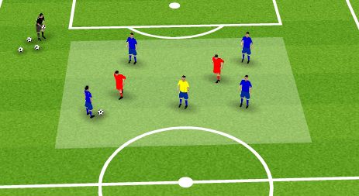  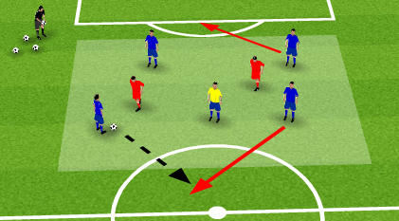 | Organisation/Explanation:  -5v3 + 1 neutral (Neutral plays with team in BP).  - Grid  - 10 Balls  - 2 sets of bibs, 1 extra colour for neutral player  Blue team must make 10 passes to score a point.  If Reds take BP then they can make 5 passes for a point. (Once point is scored, BP continues with same team).  1 Blue player ONLY at any one time can move outside of grid to receive unchallenged.  Same set up as above apart from 2 Blue players can now make runs to receive outside the grid, but can only be opposite sides of the grid.  NB. Neutral player to be limited to 2 then 1 touches.
Team Task: Well-timed and effective forward runs off the ball, to receive in advantageous positions.
Opposition – Can you stop Blues playing out and gaining an advantage?

Player Tasks:  Ball player look to get ball to forward runner when possible.  Player who is being marked, make run outside when possible to create space.  Neutral player make quick one touch passes occupying central positions between opposition. | Coaches Cues:  Quality of pass, weight and distance  Awareness to create space  Move ball quickly  Quick Switches of play to split opposition  Communication for off ball movement  Usage of Neutral player to create passing triangles

Game Training:
Organisation Diagram:  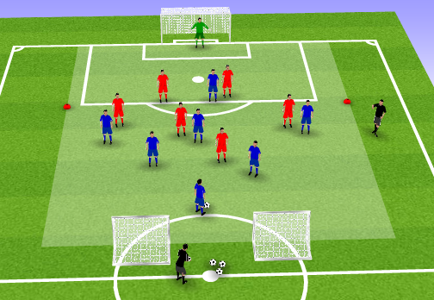  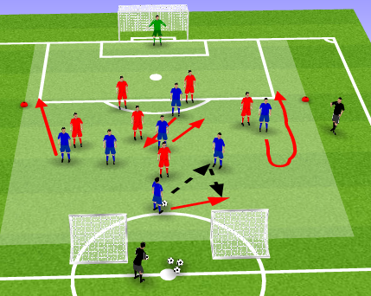 | Explanation:  - 9 v 8+1 GK (opposition)  Players:  Blue – 2,3,5,6,8,10,7,11,9 Formation: 3-3-3  Opp – GK, 3,4,6,8, 10, 7, 11, 9 Formation: 1-4-3-1  - 2 markers for offside line and or linesmen  - 2 mini goals (not too wide apart so defending is realistic)  - Coach with balls at SP (start position) between mini goals  - Playing area to be increased to full width and up to half way line IF/WHEN needed or depending on pitch size.  Play start point is always from coach SP to Blue #3. #3 must have BP before reds can press.  Blues score by shooting and scoring into the big goal.  Reds score into either of the mini goals.
Team Task:
- Play into #6 and #8 once 7,11,10,9 have made movement and forward runs to create space centrally.
- Opposition: Attempt to man mark Blue 7,11,10,9 when possible
Player Tasks:  #6,8 – When our df has possession, attempt to get into a position to receive facing forward with least touches as possible.  1. play forward whenever possible  2. Play sideways if you must  3. Play backwards if you really need to.  #9,10 – Offer short and deep option’s to receive when we have bp in M1/3.  #7,11 – Ensure that all off ball runs are not straight, and they include change of direction. E.g come inside to go out, drop off to move forward.  #2,3,5 – Look to play into #6/8. if they can’t face forward, look to receive from them again.  GK – Be available to receive from df unit | Coaches Cues:  7,11, pull markers towards ball then turn and take them away with width. If #6,8 pass backwards ensure we have maximum width for a direct pass wide.  10, When 6,8 are facing forward in M1/3, interchange and rotate with 9, float in spaces made by width and length created.  9, When are ball carrier is facing forward in M,A1/3, look to stretch defence long and choose when to drop deep rotating with 10.  6,8 movement to receive when our df unit has bp facing forward  2,5 – When GK has ball at feet push high and wide, further forward than 3. 3 t o drop and split to receive from GK when GK has BP.

Training Game:
Organisation Diagram:  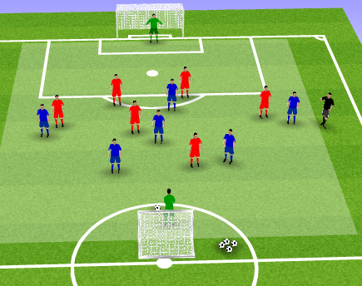 | Explanation:  9v9  Blue – 3,4,6,8,10,7,11,9 Formation: 1-2-3-3  Opp – GK, 3,4,6,8, 10, 7, 11, 9 Formation: 1-4-3-1  Normal rules apply with SP at each GK instead of corners (If blue team wins corner then their Gk starts). Throw-ins as normal.  Watch and evaluate to identify tasks coached previously in Game Training.  Stop match only if totally necessary.
Evaluation:

Ensure that the focus is kept on the quality and ability of making forward runs and not primary central movement. Emphasis on the forward runs is needed to create the space in Central areas for the forward runners to then receive.

Keep a watch on pitch size and grid size all dependant on which training pitch we use. Take care of watching player’s movement and energy to identify if size adjustments need to be made.

All session components were relevant and built into each other nicely. Players kept lively throughout and understood expectations easily.

FFA Session Plan
Playing Group: Kotoku Royals | Session No: |  | 2 | Date: | 22nd March 2017
Main Moment: | BP
Football Problem: When play enters the A1/3, possession is lost due to poor movement from #7,9,10,11 and the play breaks down, increasing chances of being counter attacked.
Objective: In this session I aim to improve combination play between our attacking players #7,9,10,11 in the A1/3.
Warm up / Passing Practice
Diagram:  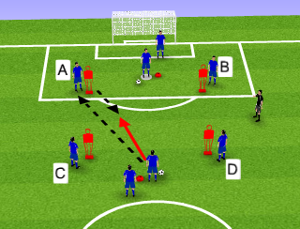  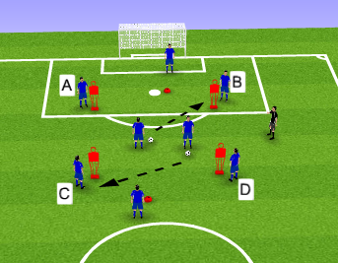 |  | Organisation/Explanation:  -18 players, 2 x 9  - 4 maniquins per group  - 2 cone markers per group  - 6 balls ber group  - Set up in pitch specific area  1) Ball player at each end rwb into the grid and must pass and receive to each corner A,B,C,D  Once all players have been played then the ball player passes it to the opposite start position and sequence starts again.  A,B,C,D must move off marker to receive and return the pass to make it as realistic as possible.  Ball player to use 2 touches, 1 to receive/turn and 1 to pass to next player.  Players change positions on coach’s cue.  2) Free play.  Ball players start inside grid.  Ball player can choose where to play and must communicate if they want a bounce pass in which A.B,C , D moves into the grid with ball or one-two, turn and make another pass.  Players waiting on the outside also get involved and are constantly changing positions while waiting.  One to Two touches encouraged.  Static and dynamic stretching throughout at rest times.

Positioning Game:
Diagram:  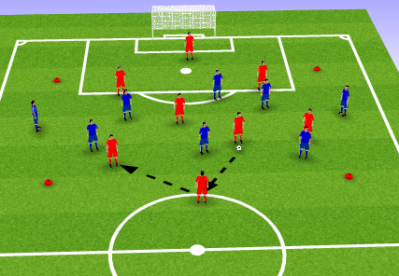  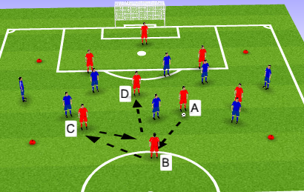 | Organisation/Explanation:  -18 players, 8v6 inside grid (2 are Neutral in yellow)  -2 players from each team locate outside opposite sides of grid.  - 4 cone markers  - Bag of balls  1) Blue v Red with neutrals playing with team in BP.  To score a point, team should play outside grid, and outside player needs to find a different player inside grid as a completed pass.  Player who passes outside grid changes positions with outside grid player.  2) Same principles as above but to score a point, the player who receives pass from outside to in, must complete an extra pass with player not losing BP.
Team Task: Make sharp small passes to combine inside and outside grid players.
Player Tasks:  Outside players to be available to receive and play back quickly.  Once ball passed outside, 2 or 3 options must be given for outside BP; left, right, central (long)  Combining players to move ball quickly out of crowded area | Coaches Cues:  Quick tempo  Proactive off ball movement  Quality weight of pass  Switch play  Use BP advantage of numbers  Know your next pass on receiving

Game Training:
Organisation Diagram:  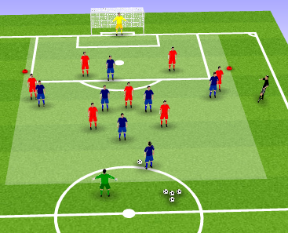  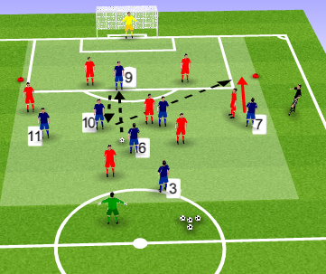  4 | Explanation:  - 18 players, 9 v 9 (2 GKs)  - Blues: 1/2/3/3 #1,3,4,6,7,8,9,10,11  - Reds; 1/4/3/1  - cone markers for offside line  - balls ready at SP  Blues play and shoot towards the goal. Goal = 1 point  Reds play and PASS ball into Green GK in target area to win point.  Start position when ball is out of play is always with GK in target zone who then plays it into Blue #3 or 4.
Team Task:
Constantly move into different space after passing and ensure that emptied positions are filled by a different player. (Encouraging quickness of play and rotation). Keep distances to enable combinations. Opposition TT – Press the ball carrier.
Player Tasks:  #3/4 - Change distribution locations (looking to not play into same area twice in a row).  #7,9,10,11 – Only receive a pass from 6/8 once you’ve moved into another position (e.g. 10 receives in 11 slot)  #6/8 – Look to pass into space where rotated player is about to move into. | Coaches Cues:  #3,4 – Look to play into 6,8, 7, 11, facing forward  #6,8 – small passes probing to break lines to attacking players.  #7,11 – come inside and rotate with 10,9? Can we combine with closest player and make 2v1 down the wings?  #10,9 – rotation with wide players?  Can you drop towards ball and show for bounce passes to link and combine?

Training Game:
Organisation Diagram:  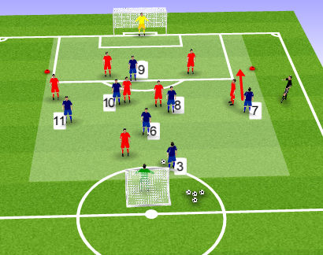 | Explanation:  - 9 v 9 (2 GKs)  - 2 big goals  -bag of balls  - off sides where possible  Watch and evaluate learning from coaching from the session.  Encourage good tempo from the side.
Evaluation:
Take care of overcrowding in positioning game or players becoming too idol. Keeping the tempo high ensured everyone was involved getting good touches. Next time I believe 2 less players inside the grid would work better.
Keeping high tempo encouraged the quickness of passing to create effective combinations between the attacking players.

FFA Session Plan
Playing Group: Royal Blues F.C | Session No: |  | 3 | Date: | 2nd April 2017
Main Moment: | BP
Football Problem: Our defensive unit are unable to play out from our D1/3 and build up through the 1/3s. This is caused by incorrect positioning to receive the ball.
Objective: In this session I aim to improve the ability of #2,3,4,5,6 to play out from our D1/3.
Warm up / Passing Practice
Diagram:  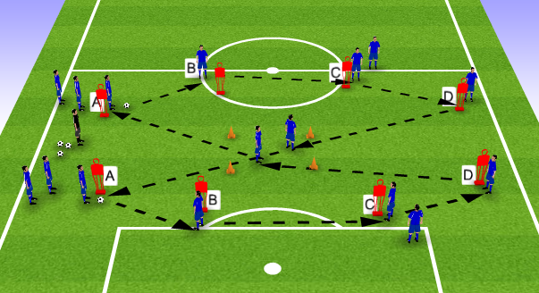 |  | Organisation/Explanation:  - 18 Players  - 8 Mannequins  - 4 cones  - bag of balls  -Set up in specific problem area of field  A starts with ball and passes to B to C to D to player in central grid, then pass into opposite A to start sequence again.  Ball player follows the pass and waits for next play.  Looking to make figure of 8 pattern of play.  Receivers open body to receive on back foot.  Add balls to quicken the speed.  Static and dynamic stretching throughout.

Positioning Game:
Diagram:  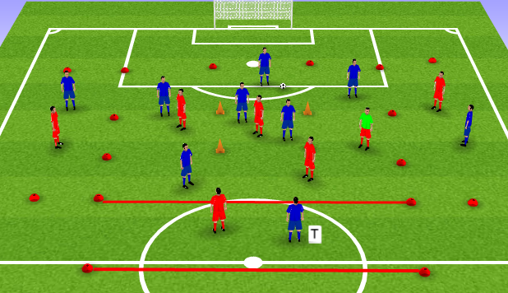  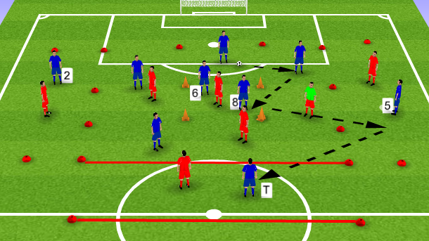 | Organisation/Explanation:  - 18 Players, 10 v 6 + 2 Neutrals  - Cone markers  - Target zone  - channel zones  - Balls  2 Blue v 1 red in central grid  1v1 in channels  2 Blue v 1 in Target zone  Blues must make at least 5 passes before finding a target player in target zone with a pass. This = 1 point. (target players passes also count)  If Red wins BP and makes 4 passes they get a point.  Players must stay in their zones.  Neutrals play with team in BP.
Team Task: Use the central grid overload to receive from the back line and to quickly switch point of attack.
Player Tasks:  Players on goal side look to play into grid or into the wide areas.  Can the midfielders in grid rotate to receive and play out?  Wide players show facing forward and move away if marked | Coaches Cues:  Circulate/recycle play  Use grid for overloads  Receive on back foot  Sharp passes  Sharp movement off ball

Game Training:
Organisation Diagram:  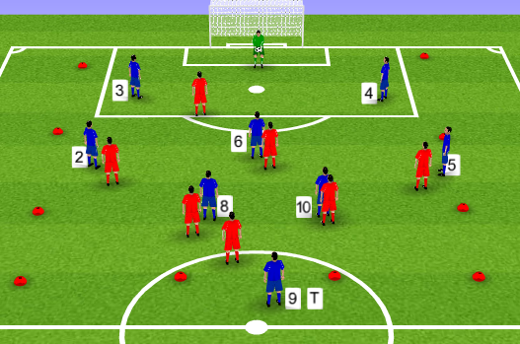  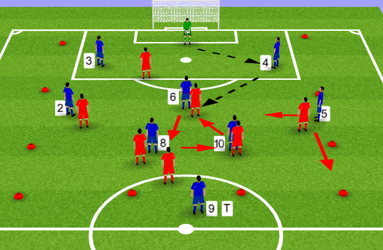 | Explanation:  - 18 Players, 9v9 ( 2 GKs)  - Blues 1,4,3,1 #1,2,3,4,5,6,8,10,9  -Reds 1,2,5,1 #1,3,4,6,7,8,9,10,11  - cones to mark wide channels  - Balls  Start position with Blue GK,who must play from the back using #3,4,6,8,10. Out of play also restarts with Blue GK.  Score is kept by goals scored by each team.  * Channels can be used with different limitations set by coach.
Team Task: Can we play out from the back with the first pass going to #3,4,(6,8 or 10 in rotation) and build through the 1/3s? Opp TT - #9, 10 decide to split defence or stay central.

Player Tasks:  GK – Attempt to start play by hitting 3,4,6,8,10 with your first pass.  #3/4 – Receive from GK facing forward  #6,8,10 – keep play moving using one touch | Coaches Cues:  #2,5 push high and wide. Should be past Red #9.  #3,4, split the penalty box. If can’t receive facing forward is GK an option?  #6,8,10 look for the rotation centrally to receive and build. If not from GK, give movement when 3,4 in BP.  #9 offer target in penalty box when ball wide, or drop to receive short when 6/8/10 in BP.

Training Game:
Organisation Diagram:  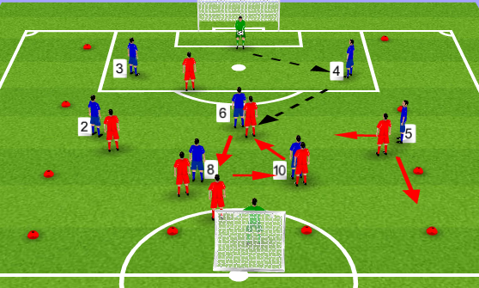 | Explanation:  - Playing area size dependant on pitch size, cones can be removed if needed.  - 18 Players, 9v9 ( 2 GKs)  - Blues 1,4,3,1 #1,2,3,4,5,6,8,10,9  -Reds 1,2,5,1 #1,3,4,6,7,8,9,10,11  - cones to mark wide channels  - Balls  Normal football rules apply. No corners, Gks to start.
Evaluation:

Each training section proved ideal stepping stone towards the Training Game. Players understood positions and duties, with positive development of being able to play out from the back.

FFA Session Plan
Playing Group: Royal Blues FC | Session No: |  | 4 | Date: | 5th April 2017
Main Moment: | BPO
Football Problem: When opposition attack with long balls into our D1/3, our defensive unit fail to deal with movement behind the defensive line from opposition #9,10 and, dealing with the aerial battle.
Objective: In this session I aim to improve my defensive unit’s ability to deal with opposition long balls on or behind our defensive line.
Warm up / Passing Practice
Diagram:  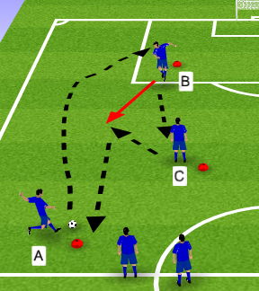 |  | Organisation/Explanation:  -20 Players, 2 x 4, 2 x 5 (2GK)  - 3 cone markers  - position specific on field  A plays high ball into B who clears.  C picks up loose ball and passes into run of B who has started their run after the header.  B plays back to the start and sequence continues.  A goes to position C, C goes to B, B goes to the start and another player takes place of A.  Stop throughout for static and dynamic stretching.  ** start the session with light passing before going into the high chip passes.

Positioning Game:
Diagram:  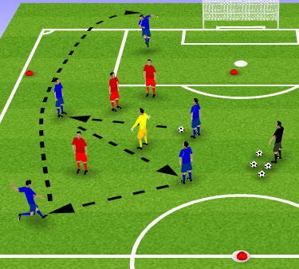 | Organisation/Explanation:  - 5v3+2N x 2 Groups  - 4 Cone Markers  - Balls and bibs  Blues to make 3 passes before a player can go outside the grid and receive a high pass.  If high pass is made, followed by a head back into the grid and a catch by a blue player inside the grid, blue team will score a point.  Red players catch the ball, red team get 2 points.  Neutral player cannot catch the ball or pass outside the grid.  If Red team win BP they can make 5 passes to score 1 point.  Teams change over after time intervals
Team Task: Can we keep good technique and get a quality jump and head of the ball back into the grid?
Player Tasks:  Outside heading player: Can we see the right opportunity to move outside the box and position our body well enough to carry out a high defending header? | Coaches Cues:  Body shape  Step back and spring into the header  Get height and distance on the header  Connect with the forehead

Game Training:
Organisation Diagram:  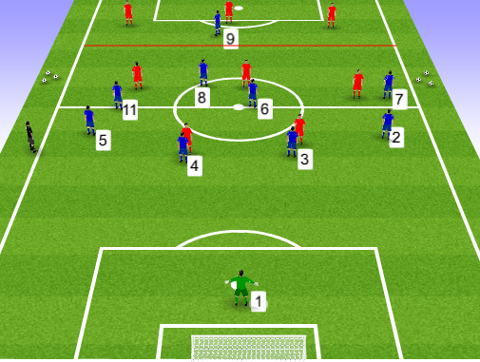  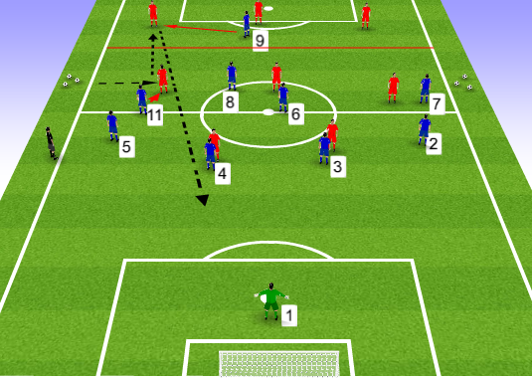 | Explanation:  - 19 Players, 9+1GK V 9 (1 GK with GK coach)  - Blue defending in a 1/4/4/1 #1,2,3,4,5,6,7,8,9,11  - Reds attacking in a 3/4/2 #2,3,5,6,7,8,11,9,10  -Target line halfway between opposition half  -Balls  -Linesmen  Start position is just past the half way line in Blues Attacking half.  Ball is played into red #7 or #11 and play is live  Blue #7 or 11 press the ball carrier forcing them to play back to red #2 or 5.  Blue #9 offers pressure from the side to ensure red ball carrier kicks long.  Blue team must push up inline with play and then defend the long ball.  Red team score in the goal. Blue team score by getting it into #9 in target area.  ** Change target zone for long ball into Blue #2,#5
Team Task: Organise defensive shape, have correct anticipation and body shape to deal with the long ball. Overall Task – Clear first and 2nd ball. Opp TT – attack the long ball.

Player Tasks:  #9 – Don’t let opp play across goal to their CB. Force them to hit long.  #7,11 – Don’t let opp wide players turn with bp. Force them to pass backwards.  #6,8 – Be first to pick up 2nd balls from our DF unit or opp att.  #3,4 – Win ariel duels. Don’t let opp striker between you and our GK.  # 2, 5 – Don’t let opp att receive behind you. | Coaches Cues:  #7,11 press the ball carrier to play back  #9 when opp play back to df, cut off square pass and force long ball’  Defensive and midfield units to push high when ball goes back. Ball moves forward towards them they drop.  GK – Correct positioning to sweep or claim.  Defending:  If hit to #4, #3 drops to cover behind, #2 picks up player #3 was marking.  #6 drops in front of #3,4 to offer protection.

Training Game:
Organisation Diagram:  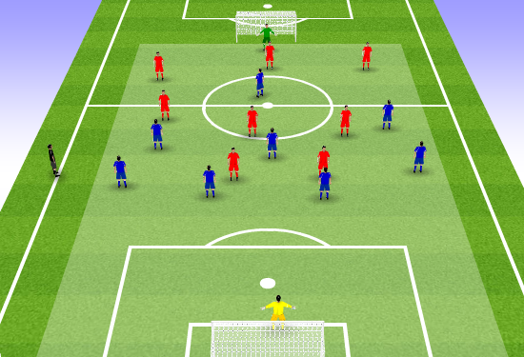 | Explanation:  -20 players 10v10 (2 GKs)  -Blue 1/4/3/1 #1,2,3,4,5,6,7,11,9  - Red 1/4/3/2 #1,2,3,5,6,7,11,9,10  Blue team to follow same principles as coached in Game Training.  Football rules apply including corners and throws.
Evaluation:

Excellent execution for the defensive unit. They started to work in sync either catching the attackers offside or gaining more confidence. The changing of long ball direction showed that defending team #2,#5 need to anticipate the pass and turn body shape side on ready to give chase if it goes over and behind them, or drop deeper so no player gets behind.

FFA Session Plan
Playing Group: Royal Blues F.C | Session No: |  | 5 | Date: | 8th April 2017
Main Moment: | BPO
Football Problem: Opposition #7,11 are being allowed to put dangerous crosses into our penalty area.
Objective: In this session I aim to improve our defensive unit’s ability to deal with opposition’s wide attacking play in our D1/3.
Warm up / Passing Practice
Diagram:  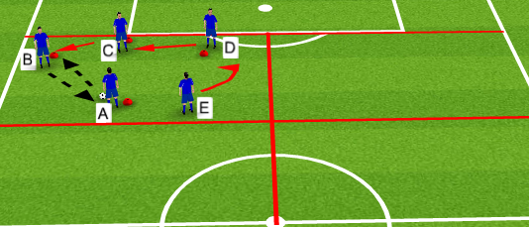 |  | Organisation/Explanation:  -20 Players, 5x4 groups.  - 4 cone markers per group  - 3 balls per group  - Half of field split into 4 grids  A starts with ball and plays one-two with B  As B receives, C presses B, D covers C, E drops in for D.  A then plays to D and the same defensive sequence happens – C presses D, B covers C, E again drops for B.  A then plays to C, B and D press from both sides.  Repeat this for 3 rounds then rotate positions; A to E to D to C to B to A.  Body shape when pressing and covering  Cover positioning

Positioning Game:
Diagram:  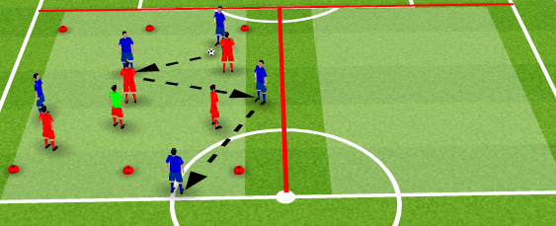 | Organisation/Explanation:  - 20 players, 2 grids of 10  - 5v4+1N  - Grid with target zone on each end  -Balls  - Bibs  Rounds are timed by coach  Blue team must score a point by passing to a player who has made a run into a target zone and receives the ball.  The pass into the target zone must come from a player outside the grid on a channel.  Only 1 player can be in outside channel at a time  Scoring is multi directional.  Reds must stop the wide pass into scoring zone and can score point by making 4 passes in BP.
Team Task: Can we stop passes from wide areas into score zone with pressure and cover – Force play centrally!
Player Tasks:  Defender closest to ball player wide to apply pressure and force direction with body shape.  Secondary players to offer cover to the presser.  Surrounding players, offer balance between covering and positioning to stop switches of play. | Coaches Cues:  Pressure with distance, body shape, speed of press  Cover, body shape to defend  Balance,body shape to block switch and also cover if other defenders beaten

Game Training:
Organisation Diagram:  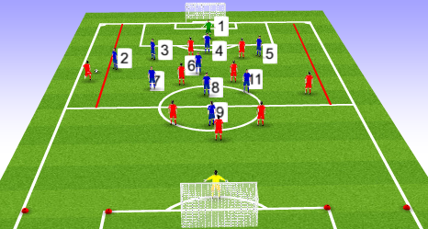 | Explanation:  - 20 Players, 10v10 (2GKs)  - Blue team 1/4/4/1 diamond #1,2,3,4,5,6,7,8,9,11  - Red team 1/3/4/2 #1,2,3,5,6,8,7,11,9,10  - Pitch up to opposite 18yd box  -Cone markers  - channels in defending half coned off  .  Start position with the attacking (red) GK  Red team get 1 point for a goal through the centre and 3 points for a goal assisted directly from wide area (cross within the channel grids)  Blue team get a point for each corner they win (corner not taken. This is to encourage counter attack) and 2 points for goal scored.  1 player from each team can be inside the channels at any one time.
Team Task: Collectively press & force the ball carrier centrally to limit opposition play down the wings.

Player Tasks:  #2,5 – Force opp wingers outside of the channel grids. If cannot, minimize danger.  #3,4 – don’t let any passes between yourselves and/or 2,5.  #2,3,4,5 – Attempt to keep 4/5 yards apart from each other (from the position next to you). | Coaches Cues:  #2,5, quickly out to wide attackers, deny/block cross  #3,4, offer cover to 2,5 when they go to press opp ball carrier.  #6 protect area in front of defensive unit at all times in BP and BPO.  #7, #11 position ready to counter when in BPO (High and wide)  #8 support 6 in BPO keeping good distance to cover and in BP when 9 has BP.  #9 hold up play in BP and link play.

Training Game:
Organisation Diagram:  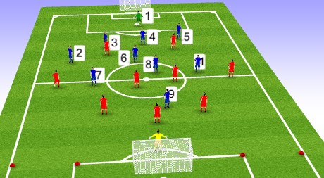 | Explanation:  - 20 Players, 10v10 (2GKs)  - Blue team 1/4/4/1 diamond #1,2,3,4,5,6,7,8,9,11  - Red team 1/3/4/2 #1,2,3,5,6,8,7,11,9,10  - Pitch up to opposite 18yd box  -Cone markers  Normal rules apply, corners and throws taken.  Look for understanding from previous coaching in session and team/player tasks from Game Training.
Evaluation:
Detailed technical defensive cues helped to deny more attacking threats from wide areas. However, in the positioning game it was too easy for attacking team to switch direction and attack the opposite score zone. Need to improve scoring scenario or keep it directional.

FFA Session Plan
Playing Group: Royal Blues F.C | Session No: |  | 6 | Date: | 12th April 2017
Main Moment: | BPO - BP
Football Problem: On winning back possession centrally in our M1/3, we are too slow to attack opposition because of slow distribution of our #6,8, enabling opposition to re-organise and get compact behind the ball.
Objective: In this session I aim to improve the speed of counter attacks from central positions, through #6,8 breaking lines from M1/3.
Warm up / Passing Practice
Diagram:  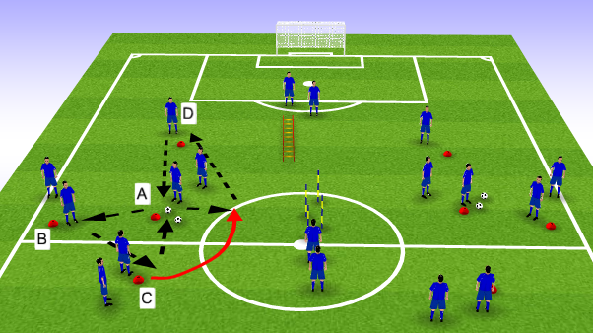 |  | Organisation/Explanation:  - 18 Players  - 8 cones  - 1 x ladders  - 4 poles  - Balls  - Set up in M1/3,  - 7 players per grid, 4 players central grid  Play starts at A, to B to C. C then plays give and go with A and then passes to D.  Players follow the pass apart from when A plays to C in the give and go.  Once C has passed to D, C goes into the centre grid.  Once player completes ladder they join left grid. Once player completes the poles they go to right grid. So there is always a rotation. The sequence goes Left grid, centre, right grid, centre and vice-versa.  - Player movement off ball away from cone to receive.  - 1 touch control then pass.  - Communication

Positioning Game:
Diagram:  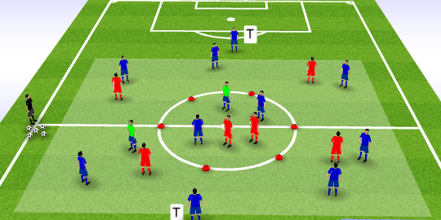 | Organisation/Explanation:  - 18 Players  - 8 v 6 + 2 T + 2 N  - grid set in M1/3  - 2v2+1N inside half way circle.  Blues can score a point:  - Get ball into centre circle  - N player must pass back into the grid, 3 passes to be made and then a T player must be found outside the Grid.  Reds score a point by:  - Make 5 passes ( can use T players to rebound but pass doesn’t count).  Development;  Blues now must pass the ball through central N player before can change direction to score to a T player.
Team Task: Get central N player on ball as soon as possible and use combination player to find T player.
Player Tasks:  Centre Circle players – quick passes to find N player. Empty spaces pass and move.  Players inside grid – combine quickly and position yourself to move the ball into target areas.  Opposition – in BPO mark N players closely | Coaches Cues:  Quick passing  Off ball movement to empty spaces  Change direction of attacks/Switches of play

Game Training:
Organisation Diagram:  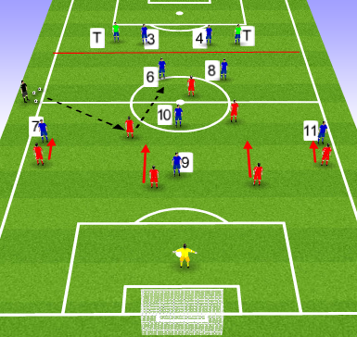 | Explanation:  - 18 Players 8v8(1GK) + 2 T  - Blue team 2/3/3 #3,4,6,8,7,11,10,9  - Red Team 1/4/2/1 #1,2,3,4,5,6,8,9  Blues must score in the goal.  Reds must hit either Target player for a point.  SP is with the coach who plays into Opposition (Red ), they then play into blue #6 or 8.  As soon as Blue receives the ball then play is live BUT, only Blue 6,8 and red #9 can vacate the area between halfway line and grid line.  Blue #6 or 8 must then distribute the ball forward.  Once #6 and 8 play ball out, blue #3 and 4 can come into play as defenders.
Team Task: How quickly can we get the ball into 10,7,11,9 in dangerous acting positions in our A1/3, after regaining possession? Opp TT – Units push up as start pass is made into Blues.

Player Tasks:  GK – After an opp attack and on winning BP, start an attack where we can finish with a shot on target after 4 seconds in BP.  #6/8 – Start a dangerous attack as quick as possible. (coach to add time limitations).  #7/11 – finish individual play with an effective cross or shot on goal.  #9/10 – shoot on sight | Coaches Cues:  #6,8 – Be more direct and hit players who are in front of you. Look for 9 if showing short or 10 if can face forward. Run with ball to break lines?  #7, 11 - when 6/8 are in BP Can we offer good width and create space between the lines to receive on the turn or run onto a forward pass?  #10 Float between opposition Attack and midfield to receive in space between lines.  #9 Occupy space between CB and FB in turn freeing up space centrally. Drop deep and look to combine with 7,11.

Training Game:
Organisation Diagram:  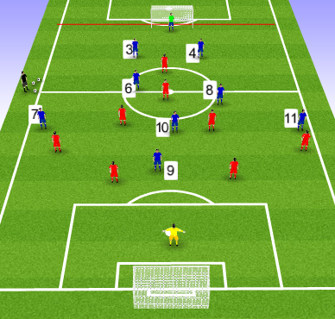 | Explanation:  9 v 9  Blues – 1/2/3/3 #1,3,4,6,8,7,11,9,10  Reds – 1/2/3/3 #1,3,4,6,8,7,11,9,10  Normal football rules apply.  Looking for previous coaching points with the main focus on ball distribution from #6 and #8.  - Are the moving the ball quickly enough?  - Are they trying to be positive facing and playing forward when possible?
Evaluation:
General concept very helpful in improving #6 and #8 mind-set and by end of session was looking to break lines quicker. Must be remembered, if the forward pass is not on, it’s ok to move the ball sideways or back, to find a better position to then play forward.

FFA Session Plan
Playing Group: Royal Blues F.C | Session No: |  | 7 | Date: | 15th April 2017
Main Moment: | BP
Football Problem: When opposition are marking us tightly in A+M1/3, our #6,7,8,9,10,11 are having difficulty shifting the ball to move opposition positions and hold onto possession.
Objective: We will improve the ability and speed of play for our M+A units to keep BP in M+A1/3s against tight marking opposition.
Warm up / Passing Practice
Diagram:  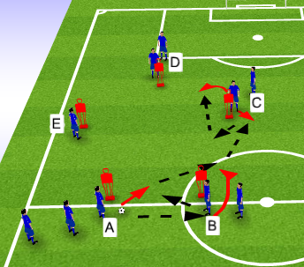  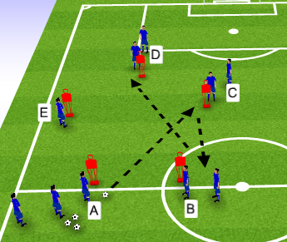 |  | Organisation/Explanation:  - 20 players, 2 grids x 10 players  - 10 mannequins  - balls  - Grid setup in M+A1/3  1) Passing sequence A to B to C to D to E to A.  A passes into B who sets it back to A and spins around mannequin to receive again from A. B then plays to C and sequence continues.  After pass, player follows pass eg, A goes to B, B goes to C  2) Passing sequence A to C sets to B to D sets for C to A sets for E  ( now the pass misses a place and goes out back and through)  Player movement moves onto to next one A to B to C to D to E to A  * start with 2 touch to keep pace slower then can build up to 1 touch  * look for dynamic movement away from mannequins  * Add extra balls later when sequence is learned and needs quicker tempo  * Dynamic and static stretch during two touch phase when tempo is slow.

Positioning Game:
Diagram:  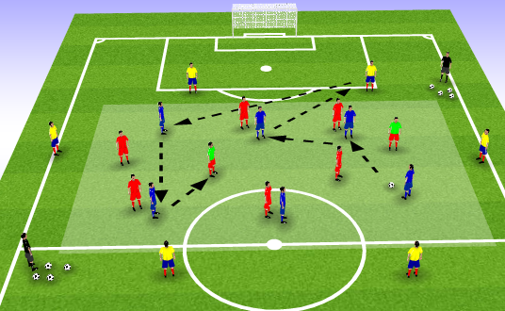 | Organisation/Explanation:  - 20 Players, 6v6v6+2N  - Grid 30 x 25  - 6 v 6 +2N inside grid, 6 bouncers on outside  Teams must reach 50 completed passes to win  Team in BP can use outside bouncers but there passes do not count.  N passes DO count.  If there’s a turnover, play continues and passes keep scoring from last count Eg, red win bp and then blues win it back.  Winning team stays on and losers change with outside bounce players  Time limit and if target not reached, closes to 50 wins.  * Can change amount of touches, including different limit for N players. N players can be #9 and #10.
Team Task: Can we complete the pass, empty space and fill new space? Opp TT – Man mark when possible
Player Tasks:  N players – Can we change direction of play as quick and often as possible?  Ball Player – 1st pass option to N (unmarked)  2nd pass option to another player, 3rd passing option to outside bouncer.  All players empty space after pass, and different player to fill the vacant position. | Coaches Cues:  Lively movement off ball  Quick, crisp passing  Keep ball moving  Know your pass before receiving  Give and go

Game Training:
Organisation Diagram:  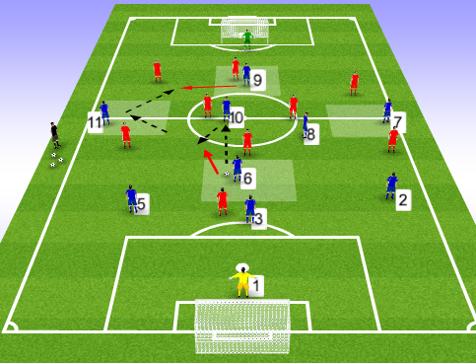 | Explanation:  - 20 Players, 10v10  - Blues 1/3/3/3 #1,2,3,5,6,7,8,9,10,11  - Reds 1/3/3/3 #1,2,3,5,6,7,8,9,10,11  Only 1 touch can be had inside the 4 grids (for Blue team only)  Goal only counts if ball has been passed from 2 grids in build up of goal. I f opposition win BP then blue team lose their ‘grid build up’ count.  Start position is from coach playing into Blue team, or from GK on coach’s command.  No corners.  Both teams must score into the goal. Most goals wins.
Team Task: Can we make quick play from the grid areas and finish with a goal scoring opportunity? Opp TT – Man Mark

Player Tasks:  2,3,5 – Look to play forward when possible/break lines with pass or rwb.  #6,8,10 – Use one touch if not facing forward  #7,11 – use two option; 1. Run direct to cross/shoot, 2. Play into 9 feet.  #9 – play with back to goal and link with 7,11 | Coaches Cues:  GK – Good positioning ready to receive if needed.  6 , 8,10,be ready to receive inside grid and play out quickly with give and go.  7, 11 – Keep good width looking to receive one way and play out the other.  9 – drag marker out of grid and to receive and move back centrally. When 7,11 in BP come short for feet.  M+A units play out move out and empty position.

Training Game:
Organisation Diagram:  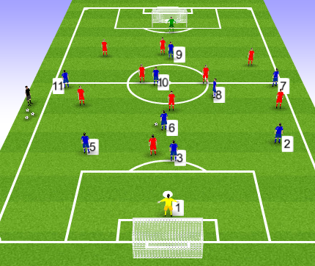 | Explanation:  - 20 Players, 10v10  - Blues 1/3/3/3 #1,2,3,5,6,7,8,9,10,11  - Reds 1/3/3/3 #1,2,3,5,6,7,8,9,10,11  Normal football rules apply.  Look for coaching points from previous. Keep close attention to the quickness of passing and off ball movement into space to receive.
Evaluation:

Lively session with players looking to play and receive in same move. In Game Training needed to explain that players don’t always have to stay in the grids, but they must have passed twice from them before scoring.

FFA Session Plan
Playing Group: Royal Blues F.c | Session No: |  | 8 | Date: | 22nd April 2017
Main Moment: | BP
Football Problem: Wing attacks have been unsuccessful and #6,8,10 are struggling to create any advantage in the crowded central areas of M1/3.
Objective: I aim to improve my team’s ability to create numerical advantage in the M1/3 by switching play or have defenders breaking into the midfield line.
Warm up / Passing Practice
Diagram:  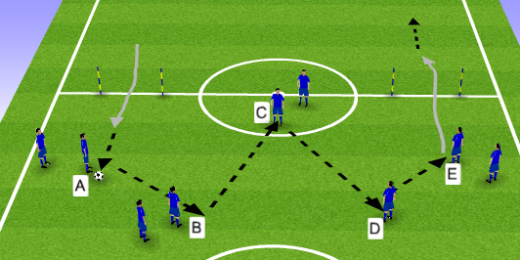 |  | Organisation/Explanation:  - 18 Players, 9 on each side to start.  - (both halves have same set up positioning, just not shown in picture  - balls  - 4 posts  A’s start with the ball and pass anti-clockwise across the pitch.​  When E’s receive the ball the look to drive forward through the gate.​  Every pass is followed. ​  Coach call change in direction when understanding and desired intensity reached.​  Note there is no cones, only cones for the gates to dribble through. which offers free movement for players to move ball across the pitch,  Progression: A and E now play a one-two and receive on the overlap. Players follow their pass as previous.  - Quality of pass  - Body position to receive  - Change of dribble speed to drive

Positioning Game:
Diagram:  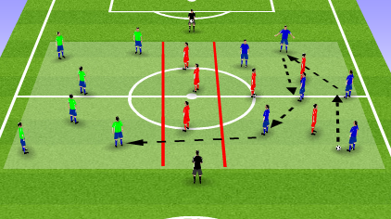 | Organisation/Explanation:  - 18 players  - 6v3 in one grid and 6v3 in one grid.​  - 3 teams  -balls and bibs  - Grid in M1/3 with central tunnel  Ball is played in from the side to begin with.​  ​  Blues move the ball around in the grid until the opportunity is right to switch play to the other grid and the 3 red players will go in between the grids and remaining 3 players will go into other grid to win the ball. ​  3 passes to be made in each grid before the switch. 1 switch = 1 point.​  Defending team score appoint for every 3 passes completed.  Progression: all 6 defenders can push into same half of grid.
Team Task: Can we quickly build up keeping BP and find the right opportunity to switch play
Player Tasks:  Attacking players ​  - Look to position yourself to create a quick switch.​  - Look to split and make it hard for red team to mark ​  - Can you draw red team to one side of the grid creating space​  for quick switch.​  ​  Defending players​  - Look to press hard forcing the ball into the sidelines​  - When ball is won and game goes to 6v5 use this time to recover with the ball.​ | Coaches Cues:  - When you receive the ball look to see if there is a good opportunity to switch play if not be patient and keep the ball . ​  - ​  - When in possession make the grid as big as possible​  - When ball is on the sideline can there be options left , right ,center and far.​

Game Training:
Organisation Diagram:  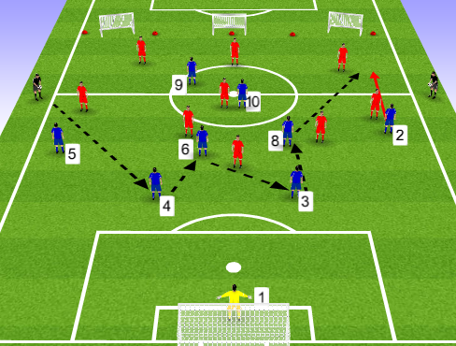 | Explanation:  - 18 players, 9v9(1GK)  - Blue 1/4/3/1 #1,2,3,4,5,6,8,9,10  - Red 3/3/3 #2,3,5,6,8,9,10,7,11  Red team have got 8 seconds to score into the big goal.​  SP – is anywhere in DF unit including GK.  Blue team score by getting a defender #2,3,4,5 to receive a pass between half way line and cones area.  Progression: Score into small goals.
Team Task: Can we get a defender breaking lines and receiving in our A1/3 (real size pitch M1/3).

Player Tasks:  #3&4​  - If there is clear space in front of you drive forward​  - Look to move the opposition No.9 away from the central area so switch can be made​  - If been pressed by front 3 can we bounce out using No.6&8​  - Look to drag opposition No.7/11 inside freeing space up for No.2/5 to be released when in possession​  #6/8​  - Support 3 or 4 if they need a bounce pass or to get between them to face forward and pass.​  - Stay high to create more space for you and No.3&4.​  ​  #2&5​  - Stay high and wide when we are in BP.​  - Look to support No.3,4,6,8 when they are in possession.​  - ​  #.10​  - Look to be that extra line in support as a combination player for back 4 to get out. | Coaches Cues:  -GK as 3/4 have the BP, Position yourself as far away as possible from them without risk to be able to switch the play.​  - When you get the ball good first touch out of the body to be able to play precise pass to full No.2/5​  #3&4​- When the transition from BPO-BP has happened, look to quickly get into position to create space​  - If the opposition No.9 has pressed one side, look to play out through GK or bounce of No.6/8 to allow other CB drive forward with the ball.​  #-6,8 When we have moved the opponent to one side can you receive the ball and open out and play out the other side.​  ​  #2/5- When we win possession and are switching play, quickly get wide to stretch opponent.​  ​  #10- Move to see the ball at all times and bounce out to players to create the overload.​

Training Game:
Organisation Diagram:  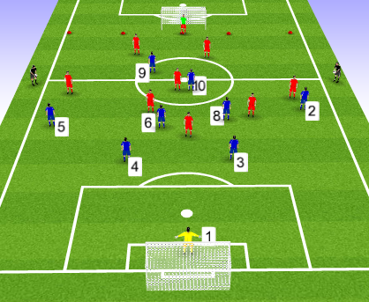 | Explanation:  - 18 players, 9v9(2GK)  - Blue 1/4/3/1 #1,2,3,4,5,6,8,9,10  - Red 1/4/3/1 #1,2,3,4,5,6,8,9,10,  Normal game rules apply;  Still use the opp A1/3 as reference to judge if defenders are getting forward to create overloads.
Evaluation: Right objectives to solves the problem in regards to session content but throughout the session it became apparent that the session aim was caught between switching play and creating overloads. It can combined into one, however, the intention was to switch play as a means to create an overload and not just concentrate on attacking in wide areas. Positioning practice needs to be smaller.

FFA Session Plan
Playing Group: Royal Blues FC | Session No: |  | 9 | Date: | 26th April 2017
Main Moment: | BP-BPO
Football Problem: On losing possession in our A1/3, too many players are committed to attacking positions, leaving too much space between defensive and attacking units allowing opposition to move into with counter attacks.
Objective: In this session I aim to improve my team’s ability to protect our defensive unit and space between units, on losing possession in our A1/3.
Warm up / Passing Practice
Diagram:  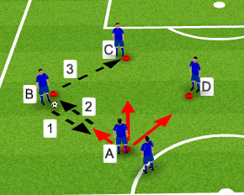  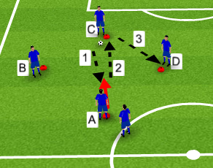 |  | Organisation/Explanation:  - 20 Players, 4 grids x 5 players  - 16 cones, 4 per grid  - balls  - 1 player on each cone ( 2 on starting cone)  B starts with the ball  A runs to meet pass from B, A receives and passes back to B.  A then makes it back to start cone, whilst at same time B passes into C.  A makes the same run towards C, who passes for A to return the pass and move back into starting cone. At same time C passes it to D.  A makes the run to meet pass from D and plays it back, then moves back into start position as done previously.  After A has done a full round, players rotate clockwise.  *. Start with 2 touch then move to one touch  * Change direction of sequence  * have B,C, D choose who they pass to next so A must react to where ball is.

Positioning Game:
Diagram:  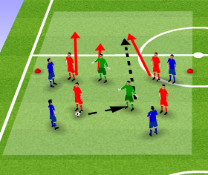  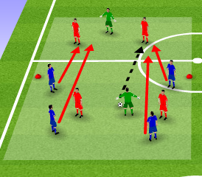 | Organisation/Explanation:  - 20 players, 2 grids x 10 players  - 4 v 4 + 2N  - Grid with cones to mark halfway line  -bibs  - balls  On winning back BP, the team must switch play into opposite half and complete 6 passes to score a point.  Passes made outside the scoring half is allowed but will not be counted as a pass towards the point.  * Development – Now ALL attacking players need to be in the same half before the 6th pass is made. (does not include N players).
Team Task: Can we recover into the half to stop the attacking team completing their pass target?
Player Tasks:  Primary – pressure on ball carrier  Secondary – cover and screening  Outer players in position to recover after loss of BP. | Coaches Cues:  Attack with intelligence (in good position to defend in loss of BP).  Pressure, cover, recover  Communicate

Game Training:
Organisation Diagram:  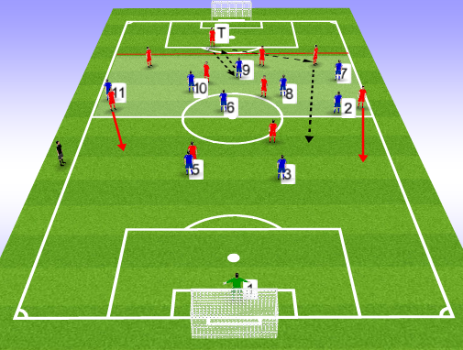  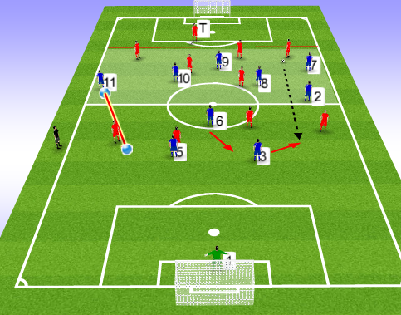 | Explanation:  - 20 players, 10v10 (1T +1 GK) *Linesmen  - Bibs, balls  - Target area  - Attacking grid  - Blues – 1/3/3/3 #1,2,3,5,6,7,8,9,10,11  - Reds – T/3/3/3 #2,3,5,6,7,8,9,10,11  Start position is with T player, who plays a one-two with a blue player. As soon as T receives back BP play is live.  Blues must have at least 7 players in A1/3 grid at start. Once game has gone live, blues can then move out if they wish.  T player can be used for any build up play.  Blues score by getting ball into T  Reds score against GK in goal.
Team Task: Move into best positions possible, to protect our defensive unit and deny forward passes. Opp TT – 5 second limit to score a goal.

Player Tasks:  #9 – Deny opp chance to recycle ball across goal/sideways.  #10/8 – Stop/block opp forward passes into M1/3.  #6 – Do not let ball enter into our D1/3 from opp forward play. | Coaches Cues:  #9 – Force ball player onto one side  #10 – pressure ball player from front  #7,11 – ball side player presses, opposite from ball side to make recovery run  #6 screen df line and cover #3/5 if they get pulled out wide.  #8 – drop to stop forward passes breaking lines  #3/5/2 – Slid across towards the threat: Pressure/cover/recovery runs  Defensive + MF units close space between units (df push up or MF #6/8 drops in to screen df)

Training Game:
Organisation Diagram:  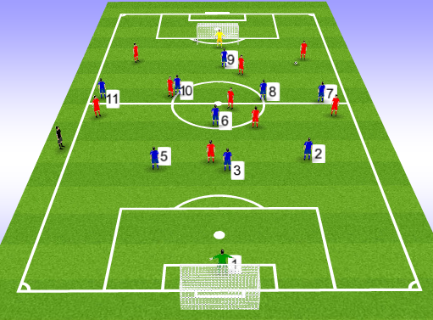 | Explanation:  - 20 players, 10v10 (2GKs)  -bibs, balls  -2 goals  - Blues – 1/3/3/3 #1,2,3,5,6,7,8,9,10,11  - Reds – 1/3/3/3 #1, 2,3,5,6,7,8,9,10,11  Normal football rules apply.  Coach to look for understanding of previous coaching from session and focusing on how the team react on losing BP.  - how quickly do we get back into position?  - screening and covering from the mf  - Sliding of the df unit
Evaluation:

If using 10 v 10 again, would be more beneficial to have defending team with 4 defenders as this is what we use in most match days. In turn, this will give more specificity to positioning for the defensive line and #6.

FFA Session Plan
Playing Group: Royal Blues F.C | Session No: |  | 10 | Date: | 28th April 2017
Main Moment: | BP-BPO
Football Problem: When our #2,5 break into M1/3 running with ball (RWB) and lose possession, opposition are attacking the vacant fullback positions in wide areas.
Objective: In this session I aim to improve the defensive unit’s ability to defend wide areas in the D1/3 when disorganised.
Warm up / Passing Practice
Diagram:  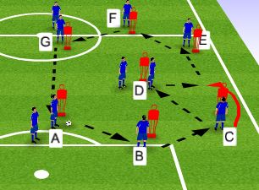  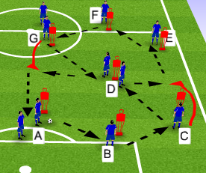 |  | Organisation/Explanation:  -20 Players, 2 grids x 10 players  - Mannequins  - balls  A starts with ball plays to B, plays to C. C one two with D and plays to E to F to G to A.  Movement is A to B to C to D (c passes to E but moves back to D), to E to F to G to A.  Development: Add a central player and extra ball.  Start with two touches to keep tempo slower while warming up and stretching.  Move onto One touch.  Rotate grids so players experience receiving from different side.  Sharp movement away from mannequin  Crisp passing, good weight of pass

Positioning Game:
Diagram:  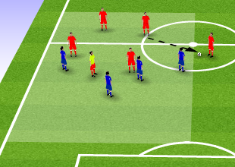  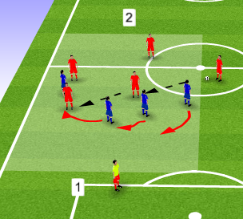 | Organisation/Explanation:  - 20 players, 2 grids x 10  - 5 v 4 + 1 N  - Blues def, reds att  - balls, bibs,  - Lanes outside both widths of grid  To score a point reds must play a wide lane before passing to N player in end zone 1 or 2. Coach shouts 1 or 2 and that’s the direction of play.  Defenders cannot go into the outside lane.  Reds score a point by making 5 passes in BP.  Development: On winning BP, reds can now score 2 points by taking ball into opposite end zone to the attackers scoring zone.
Team Task: Prevent passes into wide areas and forward play from wide areas.
Player Tasks:  Primary defender – block/delay ball player, win ball if possible.  Secondary – cover ball presser and block forward passes.  Outer defenders – offer balance between cover defender and watching for opportunities to win BP in front or behind.  Recovery defender – recover back into defensive unit to become organised as quickly as possible. | Coaches Cues:  Pressure on ball player  Cover the presser  Offer balance close to ball and away from ball  Recover and reorganise quickly  Communication  Anticipate and read passes

Game Training:
Organisation Diagram:  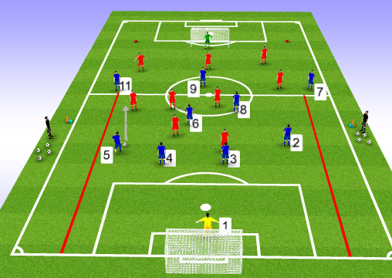  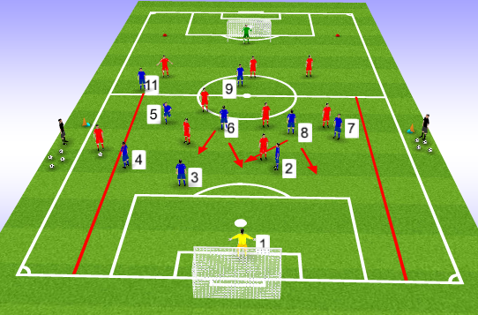 | Explanation:  - 20 players, 10 v 10 (2 GKs)  - Blues 1/4/4/1 #1,2,3,4,5,6,7,8,9,11  - Reds /1/3/3/3 #1,2,3,5,6,7,8,9,10,11  - 2 goals  - balls and bibs  - Blues defending half has wide lanes both side  Start position with coach either side, plays into Blue #2 or 5.  #2/5 RWB into M1/3 and when past the cone markers either side of pitch, they pass into Red #7 or 11. Play is live.  Red #7/11 drives into wide areas to create scoring opportunities.  Red team must have played into a wide area during build-up of a goal.  Blue team have 6 seconds to try and score when winning back BP.  Restarts again start with coach when players are reset into position and until coach changes the starting point or rule.
Team Task: Can we delay or deny the opposition’s creativity from both wide areas and force them to play back.

Player Tasks:  #3/4 – stop or deny cross from opp wingers and clear the threat.  #11/7 – be quicker than our 2/5 in racing back to recover | Coaches Cues:  #1 control area and correct positioning to sweep behind defence.  #2/5 when in BP make aggressive forward runs. When in BPO press high to win the ball.  #4/3 – Primary, Anticipate wide threat and press ball player in hole left by 2/5. Secondary offer cover to primary defender.  #2/5 defending – recover from the RWB while the opposite FB drops in positon left by the covering Centre Half.  #6/8 look to screen central from wide to central pass. Check runs where needed to cover gaps in defence.  #7/11 – recover where possible and be ready to counter in position when win back BP  #9. Force play of opposition if they play it back. Cut off options to swtich play.

Training Game:
Organisation Diagram:  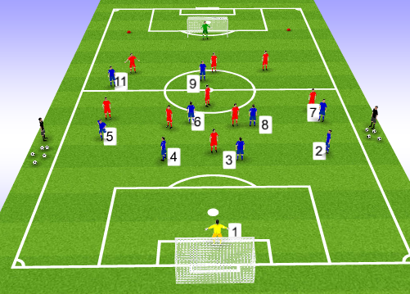 | Explanation:  - 20 players, 10 v 10 (2 GKs)  - Blues 1/4/4/1 #1,2,3,4,5,6,7,8,9,11  - Reds /1/3/3/3 #1,2,3,5,6,7,8,9,10,11  - 2 goals  - balls and bibs  Normal game rules apply.  Check for understanding of all tasks coached in Game Training section.
Evaluation:
The positioning game at times, caused difficulty for the defending team to keep scenario themed shape, due to the quickness of direction changes. Worked better when only one direction to concentrate defending. Ideally add more options to restart ball position in Game Training, to allow #2/5 to recover.

FFA Session Plan
Playing Group: Royal Blues FC | Session No: |  | 11 | Date: | 2nd May 2017
Main Moment: | BP
Football Problem: We are struggling to break down teams who defend narrowly in the M1/3 & D1/3, resulting in not breaking down the opposition and the loss of possession, into a counter attack.
Objective: In this session I aim to improve my team’s ability to create effective attacks in wide areas of opposition’s M1/3 & A1/3.
Warm up / Passing Practice
Diagram:  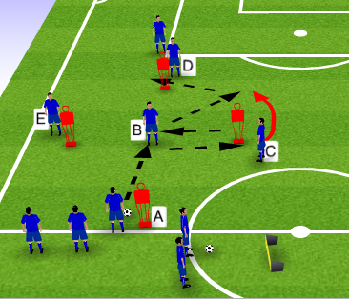 |  | Organisation/Explanation:  - 20 players, 2 grids x 10.  - 4 mannequins per grid  - balls  - 1 rebound board per grid  Passing goes from A to B to bounce wit C (c overlaps to receive) and plays to D and into B to follow same sequence as other side.  Players follow the pass position. E goes onto the rebounder.  Players stretch static/dynamic throughout 1st phase pf slower tempo.  Start 2touches to keep tempo lower, then onto 1 touch.  Change directions.  Change grids to experience both wings.

Positioning Game:
Diagram:  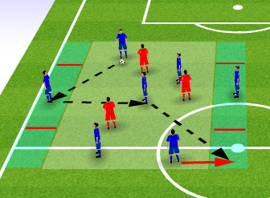 | Organisation/Explanation:  - 10 players x 2 grids  - 7 (2 wide zones) v 3 inside grid  - wide areas with target zone corners  - balls, bibs  Both wide players must stay inside their grid. Reds cannot go inside the channels.  Blues must play outside to a channel before passing to a player inside a corner zone for a point. (Must be directional scoring in opposite ends each time).  Reds can win BP and make 5 passes (using channel players) to score a point  Development – Play into wide area and rotate position with player; wide player can drive into grid with RWB
Team Task: Can we use the free players out wide to effective use with correct decision making?
Player Tasks:  Ball player – find channel players quickly.  Closest to channel player – look to receive and turn from wide players.  Furthest from channel player – create movement to lose markers and get into position to score a point. | Coaches Cues:  High tempo  Play out and support  Head check  Turn on a dime  Switch play through play maker

Game Training:
Organisation Diagram:  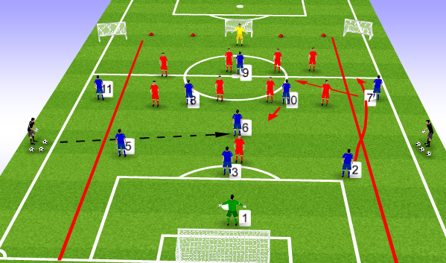 | Explanation:  - 20 players, 10v10 (2GK)  Blues 1/3/5/1 #1,2,3,5,6,7,8,9,10,11  Reds 1/4/4/1 #1,2,3,4,5,6,7,8,9,11  - 3 small goals  - 1 big goal  - bibs,balls  - Wide channels marked off  Start position with coach who plays into #6 or 8. As soon as they receive then play goes live.  Only 1 blue player can go in channel at any time. Reds cannot defend in wide channels.  Red GK can defend all goals. Reds can go into channel behind marker.  Blues must score as follows:  Wide goals = 1 point  Centre goal = 2 point (to encourage reds to defend narrow)  If switch channel to channel twice in BP = 1 point  Reds score 2 points for each goal and have 5 seconds to end each attack.
Team Task: Get players in channels on the ball as quickly and often as possible.

Player Tasks:  #6/8/10 – Receive passes between opp lines to switch play in 2 touches.  #7/11 – Receive ball centrally and play forward to #2/5  #2/5 – How many times can you get beyond our 7/11 and receive a pass from them? | Coaches Cues:  GK – positioning to start attacks when possible.  #2/5 – Can we look for overlaps when 7/11 move centrally?  #3 – support #6 to recycle and switch play.  #6/8/10 – play in between opp unit lines and look for the diagonal switch if on. One player should always drop between opp att & mf line to develop/build bp.  #7/11 – keep effective width, invert runs/position when opposite postion has BP.  #9 attempt to occupy as many defenders as possible (good position being between opp FB and CB)

Training Game:
Organisation Diagram:  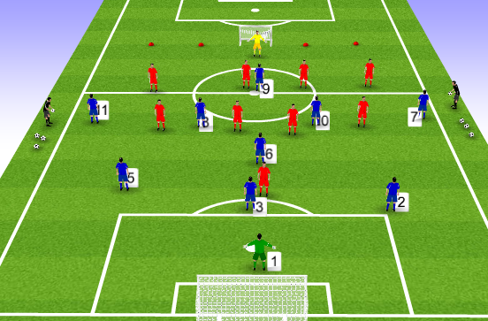 | Explanation:  -- 20 players, 10v10 (2GK)  Blues 1/3/5/1 #1,2,3,5,6,7,8,9,10,11  Reds 1/4/4/1 #1,2,3,4,5,6,7,8,9,11  Normal game rules apply.  Look for;  Understanding of using wide areas as an effective attacking option. Keeping away from overcrowded central area.  Switches of play with tempo, to change point of attack.
Evaluation:
Pitch set up for Game Training was incorrect. To be more specific, Blues should have been attacking the A&M1/3, so moving the pitch up was necessary. Blues were looking to play into 7/11 more often and recognised when forward play was blocked, they could use #10/8 to switch play. #7 and 11 also switched with direct passes.

FFA Session Plan
Playing Group: Royal Blues | Session No: 12 |  |  | Date: | 6th May 2017
Main Moment: | BP
Football Problem: Our defensive unit are losing possession when opposition use an aggressive high press on our defensive unit (#2,3,4,5,6,8) in our D1/3.
Objective: In this session I aim to improve the defensive unit’s ability to miss out the opposition press in D1/3 and bring our #7,9,10,11 into play.
Warm up / Passing Practice
Diagram:  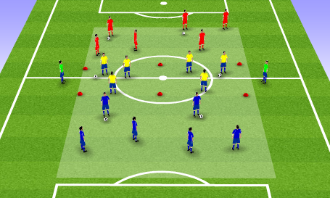 |  | Organisation/Explanation:  - 20 Players, 3 teams x 6 + 2 N  - minimum 6 balls  - bibs  - cone markers  Phase #1 – reds and blues pass between their group of 3, Yellow and green in groups of 4.  - two touches, with dynamic and static stretching  Phase 2 – Reds play pass and move, blues play pass and move in their own sections.  Yellow stay central and can receive ball to switch into opposite grid.  Greens float outside as a rebound.  Phase 3 – grids now playing vertically  Blues and reds play off yellow and if they pass and call ‘Jacks’, the tunnel team must let the ball pass through to the opposite team.  Ensure to rotate teams and the also the Green N players.

Positioning Game:
Diagram:  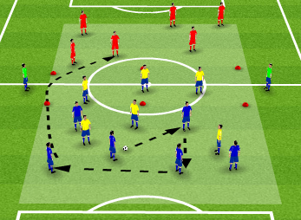 | Organisation/Explanation:  - 20 players, 3 teams x 6 + 2 N  - same grid and set up as passing practice  Team in the tunnel are the pressing team.  Blues and red must complete 4 passes and then transfer ball into opposite grid = 1 point.  Defending team can have 3 players at any time to press, the others must stay in the tunnel  N players can be used as rebounders for attacking team but their passes do not count towards the 4.  If defenders win BP, they must play it into tunnel and out to the N before changing positions with the team who lost BP.  Attacking players cannot go into the tunnel.
Team Task: pull in the defenders with build-up play before switching and clearing the press.
Player Tasks:  Ball player – time passes to draw in defenders  Surrounding players – create width and depth so can complete passes quickly and be in good position to switch across.  Non-playing team – be ready to receive in positive positions and ready to react. | Coaches Cues:  Be proactive  Quick tempo then release  Decision making to draw defenders in.

Game Training:
Organisation Diagram:  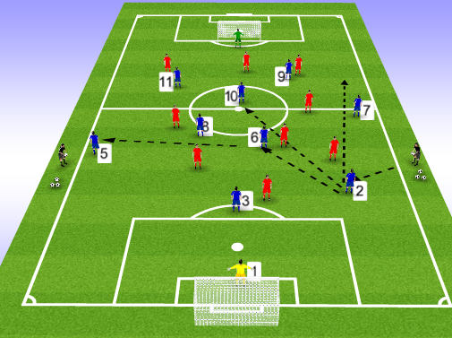 | Explanation:  -20 players, 10v10 (2 gks)  - Blue 1/3/3/3 #1,2,3,5,6,7,8,9,10,11  - Red 1/3/3/3 #1,2,3,5,6,7,8,9,10,11  SP into #3 or 5 as this is the trigger opposition looks to press.  Once player take first touch, play goes live.  Opposition has 5 seconds to score if win BP.
Team Task: When in BP ensure you are away from marker and can receive facing forward.

Player Tasks:  #1 – be ready to support ball player and play out from back or clear lines  #2/5 – Attempt to hit #10 between lines, break lines to 6/8/7/11 or clear it straight to 9?  #6/8 – look to receive from defence behind opp first pressing wave.  #10 – occupy space between opp df and mf units and receive facing forward.  #7/11 – can we create space in central areas? (keep width)  #9 – win Ariel balls and link with #10 | Coaches Cues:  GK- open body to receive when our df unit are in bp facing back.  #3 – available as balance position to switch play.  #6/8 – be available to receive when ¾ are in BP.  #10 – Be in a position to receive facing forward when our 6/8 get on the ball.  #7/11 – When we have bp in central areas, pull as wide as possible leaving space in fron to run into.  #9 – Look at DF unit body shape in BP and read any long passes coming. If MF unit facing forward look to come short between the lines and receive to feet.

Training Game:
Organisation Diagram:  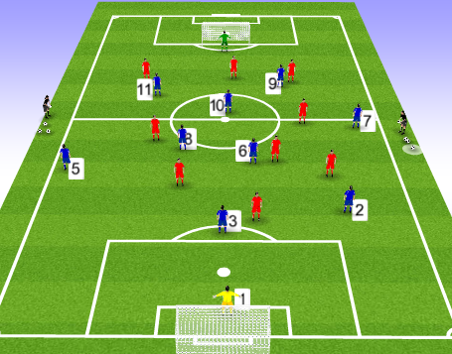 | Explanation:  -20 players, 10v10 (2 gks)  - Blue 1/3/3/3 #1,2,3,5,6,7,8,9,10,11  - Red 1/3/3/3 #1,2,3,5,6,7,8,9,10,11  Normal game rules apply  Look for understanding of;  Decision making of how to break line,  Decision to go direct if need  Confidence to want the ball/calmness under pressure
Evaluation:

Passing practice can be effective and free flowing but too crowded for grid size. Training game worked well with players off the ball working hard to find space between opp unit lines. NB – maybe its not ball player with the pressure, it’s off ball movement to create space to receive?

FFA Session Plan
Playing Group: Royal Blues | Session No: 13 |  |  | Date: | 10th May 2017
Main Moment: | BPO
Football Problem: Opposition #4 is playing out the back through our attacking unit and finding their #10, who is dropping deep into M1/3 to receive between our A&M1/3 to carry the ball.
Objective: In this session I aim to improve my team’s ability to stop opposition building from D1/3 through their #4 and into their #10 star man.
Warm up / Passing Practice
Diagram:  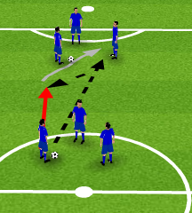  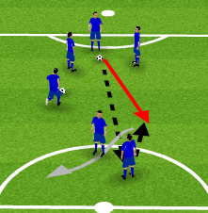 |  | Organisation/Explanation:  - 18 players, 3 grids of 6, groups x 3 players  - 1 ball per 3 player group  - no more than 8 yards between groups  1) Groups of 3 pass between themselves, warming up with steady tempo static and dynamic stretching throughout.  On the coaches’ order, one player from each group must take the ball and pass to the opposite grid of 3 players.  The passer then followers the ball to receive a one-two and then dribbles into that group.  At the same time, another player from the receiving group must play their ball into the original ball playing group. Basically doing the same but in the other direction.  Increase tempo when ready by going to one touch passing.  2) development  Bring all 6 groups of 3 into play. Players must now choose any group to pass into and receive.  Players must attempt to keep a limit of 3 in each group.

Positioning Game:
Diagram:  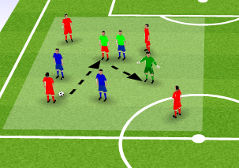 | Organisation/Explanation:  - 18 Players, 2 grids of 9  - 5 v 3 + 2 N (1 player from each team are man markers)  - Balls and bibs  Red must find their T player who is being marked by Blue T player.  To score a point red target player must find N player.  Blue must defend and deny;  a) red passing to their T player  b) Blue man marker (T) to mark Blue T player.  If Blue win the ball the must play 3 passes then get it to their T player to score a point.
Team Task: Deny opposition from playing into their Target player.
Player Tasks:  Man marker – Can you stop player from receiving and playing into the N player?  Pressing players – Deny passes into opposition Target player. | Coaches Cues:  Tight marking  Proactive reactions  Anticipate opp movement  Aggressive press on ball carrier

Game Training:
Organisation Diagram:  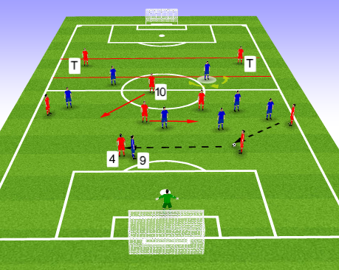 | Explanation:  - 18 Players, 8v8(1GK) + 2 T  - Blue 2/4/2 #3,4,6,7,8,9,10,11  - Red 1/4/2/1 #1,2,3,4,5,6,8,10,  SP with Red GK or coach plays into Red #2 or 5. Before red can score a point their #3 or 4 (CBs) must have touched the ball at least once.  For reds to score a point they must pass into T players.  Blues can score in the goal v Red GK.  Red team #3 is not a comfortable ball player hence why we are man marking #4 who is. Try and replicate this in practice.
Team Task: Can we press our specific pitch areas and stop their #10 receiving the ball from # 4 distribution?

Player Tasks:  #3,4 – keep high line when MF and Att units press opp ball carrier.  MF unit – Stop forward passes to opp #10? and effectively press the correct opp players in correct areas.  #7/11 – Stop opp Fbs passing forward but force play inside to #3.  #10 –Aggressively press #3 and make him try to play out or kick long.  #6/8 – Be in a position to deny split passes between our press  #9 – Stop #4 receiving bp and force play away from #4 | Coaches Cues:  #11, 10/8, 6 – when opp in bp on right wing, force play backwards to opp #3.  #10/8 – once pass is on move to opp #3, pressure him immedietly.  #9 – once opp pass towards opp #3, mark opp #4 and stop him getting into BP.

Training Game:
Organisation Diagram:  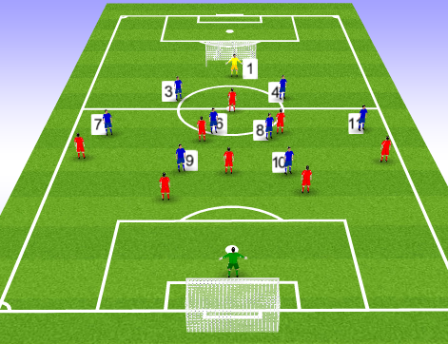 | Explanation:  - 18 Players, 9v9(2GK)  - Blue 1/2/4/2 #1,#3,4,6,7,8,9,10,11  - Red 1/4/3/1 #1,2,3,4,5,6,8,10,9  Normal game rules apply;  Watch for understanding of;  Player roles in collectively pressing.  Amount of BP opp #4 and #10 receive.
Evaluation: Passing Practice wasn’t relevant but did an effective job of warming up and creating enjoyment. Positioning game was the right idea and switched on players to mark opposition playmaker. GT very effective with players understanding their roles and instructions, denying #4 the BP and restricting their #10 of chance to receive and turn to attack.

FFA Session Plan
Playing Group: Royal Blues | Session No: |  | 14 | Date: | 13th May 2017
Main Moment: | BPO - BP
Football Problem: On winning back possession quickly and hitting our #9 with early, direct passes, #9 is struggling to hold onto possession due to being marked in our A1/3 and failing to link up play with our #7,10,11.
Objective: In this session I aim to improve our #9s ability to primarily hold up play, then link up play with #7,10,11, in our A1/3.
Warm up / Passing Practice
Diagram:  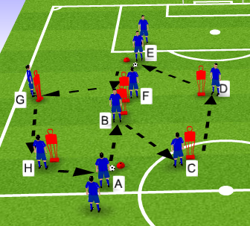  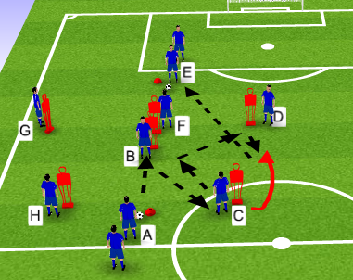 |  | Organisation/Explanation:  - 20 players, 2 grids of 10  - 12 mannequins  -4 cones  - balls  Passing sequence: A to B to C to D to E to F to G to H to A.  Two touches to start, movement away from marker.  B and F to hold off marker.  Follow the pass to next position.  Development:  B and F are now to hold off marker twice, receive a one-two and play into D.  C makes overlap and plays into E.  Each pass misses a player but player movement still follows the pass.

Positioning Game:
Diagram:  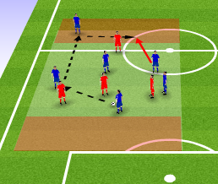 | Organisation/Explanation:  - 2 grids x 10 players, 6v4  - Grid with a target zone on each end.  - balls and bibs  Attacking team must play the ball to a #9 inside a target zone.  #9 must then play into a 3rd man runner also inside target zone to get a point. One Red can defend inside Target area.  Reds score by getting ball into opposite zone (depending which half they are)  Development – choose which player must be a #9 or must be the 3rd man to score the point on receiving.
Team Task: Can we play into our Target #9 and support him with 3rd man runs?
Player Tasks:  Ball player – can we create forward passing opportunities into #9 in target zone?  #9 (player in target zone) – Can we get into a position to receive and lay off to a support player?  Support player – can we identify when to make our run to receive from #9? | Coaches Cues:  Timing of pass  Weight of pass  Off ball movement  3rd man runs  Vision to see support players

Game Training:
Organisation Diagram:  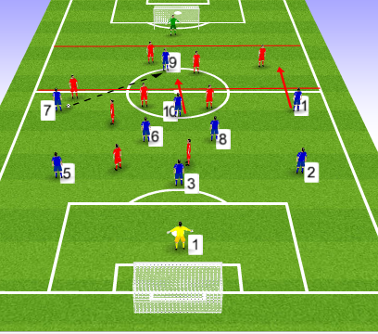 | Explanation:  - 20 Players, 10 v 10 (2 GKs)  - Blues 1/3/3/3 #1,2,3,5,6,8,7,11,9,10  - Reds 1/4/3/2 #1,2,3,4,5,6,7,8,9,10  - Balls and bibs  - 2 goals  - attacking grid in A1/3  SP ball played into Opp MF who then pass into Blue DF player.  Play goes live when Blue player receives.  To score, the ball must have been played into #9 with at least 2 other players being inside the grid during build up.  No limit of players that can be inside grid.  Red team in BP have 6 seconds to score and their goal = 2 points to encourage them to attack.
Team Task: Can we play forward into #9 with surrounding players close enough support to create combinations?

Player Tasks:  GK – Encourage DF to push up on winning BP  DF – Close the space to the MF unit on us winning BP  #6,8 – Play forward to wide and central areas to start attacking threats and allow our att unit to push higher towards #9  #7,11,10 play into #9 and support by 3rd man movement and runs? Can we penetrate A1/3 with rwb and dribble to create overloads | Coaches Cues:  Pass selection to advanced areas  #9 deal with marker first, before dealing with ball  #9 – Create space to receive and combine with supporting players

Training Game:
Organisation Diagram:  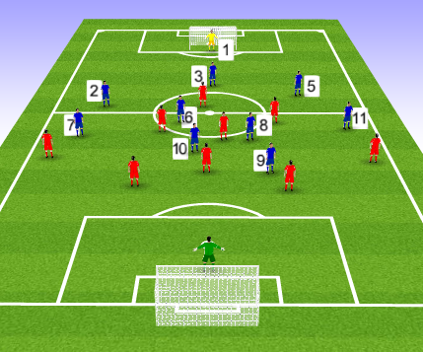 | Explanation:  - 20 Players, 10 v 10 (2 GKs)  - Blues 1/3/3/3 #1,2,3,5,6,8,7,11,9,10  - Reds 1/4/3/2 #1,2,3,4,5,6,7,8,9,10  - Balls and bibs  - 2 goals  - Linesmen  Normal game rules apply.  Look for understanding of;  Ability to feed into #9.  Support for #9.  Df unit pushing up with the attack.  GK organisation of pushing df up.
Evaluation:
Footballing problem was evident throughout all session’s phases. #9 roles rotates between players so they could feel how it was to be #9 and what service they need. Specific technique of #9 coached which was useful for all players to deal with a marker first and then dealing with the ball is easier. At times, players too concentrated on just looking for #9. It must be emphasised that the idea is to create the best angle of attack to get it to #9.

FFA Session Plan
Playing Group: Royal Blues | Session No: |  | 15 | Date: | 16th May 2017
Main Moment: | BPO
Football Problem: When our attacking unit presses opposition #2/5 in their D1/3, opposition’s #10 is receiving possession in M1/3 between our defensive and attacking units.
Objective: In this session I aim to improve our team’s ability, to intelligently press opp #2/5 as a collective unit in opposition D1/3 and stop opp #10 receiving between our unit lines.
Warm up / Passing Practice
Diagram:  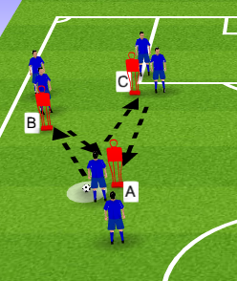 |  | Organisation/Explanation:  - 20 players, groups of a 7,7 and a 6  - 3 mannequins per group  - Balls  Passing sequence and movement;  A plays 0ne-two with B and steps up to receive before passing to C.  A and B then light press C, C plays a split pass between A and B into the next person on A starting position.  A moves to B, B to C, C to A after the pass.  Start with to touch with dynamic and static stretching.  Make tempo quicker with one touch.  Change side to pass and receive ball of mannequin.  Change which feet and side of foot to use.

Positioning Game:
Diagram:  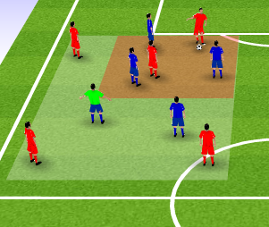 | Organisation/Explanation:  - 20 players, 2 grids x 10  - 5v4+N  -balls and bibs  Attacking team must keep BP for as long as possible. Each 6 pass sequence will make 1 point.  Defending team look to win back BP and score 1 point for winning back BP and another point for finding the N player.
Team Task: Can we force opp BP into corners and control the space to win back BP?
Player Tasks:  All players – can we half the grid and control areas of play?  Closest to ball – can we force attacker into limiting space and trick them to give up BP? (press from right and left to set up opp split pass)  3rd man of the press – can you read opp split pass and deny receiving player BP?  Outer defender – Can you take up good positioning to deny break aways from defensive press? | Coaches Cues:  Communication to position  Work as a team  Intelligent pressing  Half the grid  Force the play  Head checks for awareness

Game Training:
Organisation Diagram:  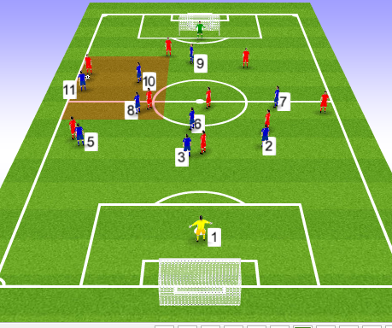 | Explanation:  - 20 players, 10v10 (2 GKs)  - Blue 1/3/2//3/1 #1,2,3,5,6,7,8,9,10,11  - Red 1/4/3/2 #1,2,3,4,5,6,7,8,10,11  Start position; Opp Gk, Coach to kick balls into opp defensive line.  Teams are to attempt to score as normal.  Blue team must attempt to score before 6 passes otherwise it’s a turnover to opposition.  Condition to add if needed: Reds must play through #2/5 at least once before leaving their half.
Team Task: Get opposition #2 and 5 on the ball as much as possible

Player Tasks:  Attacking and MF units – force play into one half of the pitch and keep it there until winning bp.  #9 Deny option for opp to pass back to GK or switch across the back line  #8 – Deny any split passes as the 3rd man point at the bottom of the pressing triangle  #6 Command the space between our defensive and midfield lines  GK – positioning ready to sweep and encourage defence to push up. | Coaches Cues:  When opp #2/5 in BP;  #11/7 Press the ball player from front or as close to side line as possible  #10 Support our 7/11 as the inner point of pressing triangle  Defensive unit – keep our lines compact and limit space between our unit lines when Opp passing

Training Game:
Organisation Diagram:  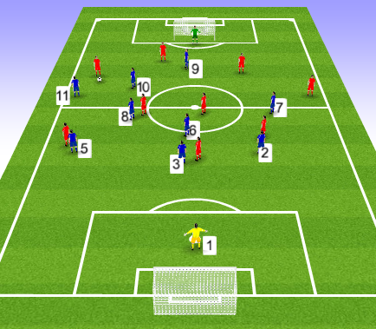 | Explanation:  - 20 players, 10v10 (2 GKs)  - Blue 1/3/2//3/1 #1,2,3,5,6,7,8,9,10,11  - Red 1/4/3/2 #1,2,3,4,5,6,7,8,10,11  Look for understanding of Game training player tasks and team task.  Normal football rules apply.
Evaluation: Whole team made conscious effort in Training Game to press as a unit. At first, some gaps being left between defensive and attacking units on the press allowing opposition to escape the press. Evident that defenders corrected this problem during the game by pushing up quicker and closing the gaps between the lines. Pressing triangle proved effective and caused disruption with opp #2/5 attempting to switch play on occasions and putting their players into danger.

FFA Session Plan
Playing Group: Royal Blues | Session No: |  | 16 | Date: | 24th May 2017
Main Moment: | BP-BPO
Football Problem: When #6,8,10 lose possession centrally in M1/3, opposition ball carrier has choice of wings to hit and are catching our #2/5 out of position with quick switches of play.
Objective: In this session I aim to improve the ability for our 6/8/10 to counter press in the M1/3, to stop opposition quickly switching play into our defensive wide areas.
Warm up / Passing Practice
Diagram:  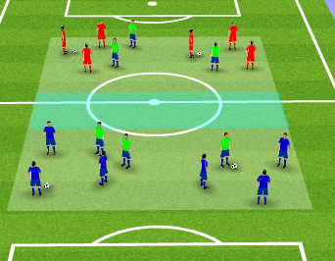 |  | Organisation/Explanation:  - 18 Players, 3x6 players.  -Blues and Red split into own zones in groups of 3.  - Greens are split between reds and blues in 3s.  - 4 balls, bibs  - grid with central horizontal tunnel  Two touch passing within small groups. Static and dynamic stretching throughout.  Develop into player movement after pass.  Develop into 1 touch with player movement.  On coach cue, green players are to run and switch positions with their opposite group.  Ensure to rotate teams who are running.  Change passing style, e.g. one bounce, no bounce, left foot only, right foot only.

Positioning Game:
Diagram:  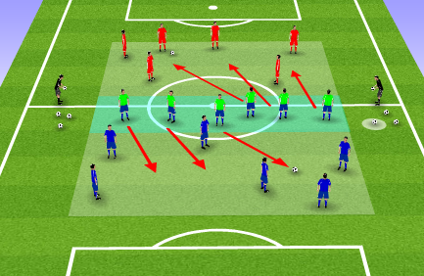 | Organisation/Explanation:  - 18 Players, 6+6+6  - Same grid as passing practice  - balls, bibs,  Blue team and red team have a ball each in their section.  They must keep possession for as long as possible in 40 second bursts,  The tunnel team split into teams of 3 and press red and blue team.  Each time the pressing team wins BP and completes a pass, the call is made and the pressing teams run to change sections. They continue with the press.  Highest number of ball recoveries in 40 seconds wins.  Each team does 3 rounds of 40 seconds then rotate.
Team Task: Collective press as a team to win back BP as quick as possible.
Player Tasks:  Primary presser/s – can we apply hard pressure to cause bad pass or loss of opp BP?  Secondary presser – can we be in a good position to press ball carrier if possession is switched? | Coaches Cues:  Quick recovery  Good tempo  Press together  Body position to press the switch  Work hard in the change over

Game Training:
Organisation Diagram:  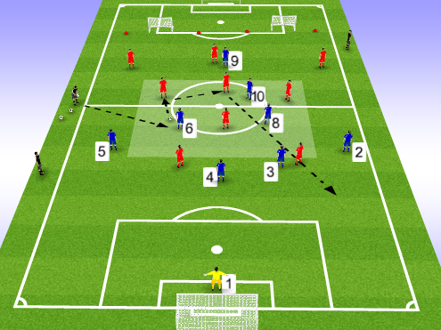 | Explanation:  - 18 Players, 9 (1GK) v 9  - Blue 1/4/3/1 #1,2,3,4,5,6,8,9,10  - Red 3/4/2 #2,3,5,6,7,8,9,10,11  -balls, bibs  - grid in M1/3  - officials  SP with coach who plays into Blue player. Player then passes into red and the game is live.  Only 4 blue players can be inside the grid.  As many red players can be inside the grid.  Red must score in the big goal.  Blues can score in either small goal.  Add blue scoring condition if coaching point needs more consistency.
Team Task: Attempt to win back possession in M1/3 as quick as possible and deny opp forward passes.

Player Tasks:  Opp TT – attempt to hit diaganols behind 2/5.  #6,8,10 – Deny opp midfielders playing forward out of the grid and win back BP when possible.  #4/3 – One of you support 6,8,10 in the m1/3 press?  #9 – Can we keep the opp defence unsettles and unable to receive if opp midfielders look to play back?  GK – Positioning to cover defence with long balls. | Coaches Cues:  Aggressive press as a unit.  Communication when pressing  Noticing opp body shape, ball carrier head up will pass short, head down will hit pass long.  #2/5 – when opp has BP, read their body language and decide if they are passing short or going to hit long behind you?

Training Game:
Organisation Diagram:  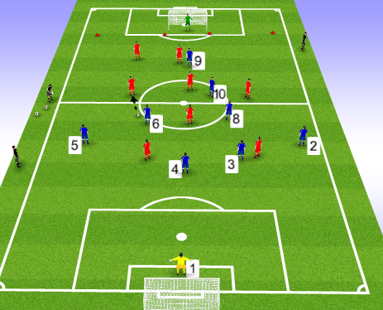 | Explanation:  - 18 Players, 9 v 9 (2GK)  - Blue 1/4/3/1 #1,2,3,4,5,6,8,9,10  - Red 1/2/4/2 #1,,3,4,6,7,8,9,10,11  -balls, bibs  Normal football rules apply.  Look for understanding and successful;  Counter pressing in M1/3 when loss of BP.  FBs body position and dealing with a direct ball in behind them.  How often does opp MF have easy possession and create dangerous switches of play?
Evaluation:
Pitch size needs to be smaller for the Training Game. Focus needs to be on the counter pressing in M1/3 and not wasting energy chasing in different areas. Game Training and Positioning worked well and understanding of tasks was evident.

FFA Session Plan
Playing Group: Royal Blues | Session No: |  | 17 | Date: | 1st June 2017
Main Moment: | BPO-BP
Football Problem: On winning possession in wide areas of M1/3, the opposition block of forward passing options and we lose possession due to our #7/11 passing back to our #2/ and putting them under pressure leading to a big kick up field.
Objective: In this session I aim to improve our ability to recycle play from our M1/3 wide areas, using our #2,3,4,5,6.
Warm up / Passing Practice
Diagram:  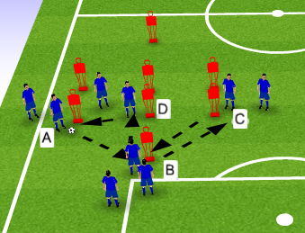  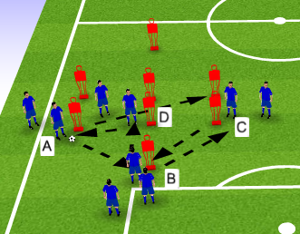 |  | Organisation/Explanation:  -18 players, 2 grids of 9 back to back  -Balls  - 6 Mannequins  Passing Sequence;  A to B to C back to B to D to A.  Movement follows the pass.  Start with two touch to keep tempo low. Static and dynamic stretching during.  Ensure explosive turning and body shape away from mannequins once warmed.  Develop into 1 touch.  Development 1:  Free play – players can choose passing options.  Development 2 (picture 2):  When A receives back from first sequence, they pass ball through into opposite grid and play continues. Both sides will be working at same time.  Add balls if tempo needs to quicken.

Positioning Game:
Diagram:  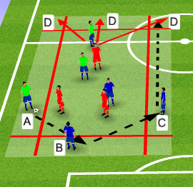 | Organisation/Explanation:  - 2 grids of 6v3 (3 teams of 3)  - grid with horizontal and vertical tunnels  - balls and bibs  Attacking team must recycle from wide grid, to central to wide to score a point; A to B to C.  Red/defending team must win back BP and pass to their team in outer channels to score a point.  Development 1:  Attacking team can still score 1 point as normal.  Or pass from A to B to C to D for 3 points.  Defending team now scores 2 points the same way as before.  Rounds are 45 seconds each then defending team rotates.  Team with most points scored wins.
Team Task: Can we position ourselves to switch BP by recycling play around the defending team?
Player Tasks:  Ball carrier - attempt to pass into player in wide positions or if already in wide area, can we pass back to shift position of play?  2nd receiver – can we have good body shape to receive from wide areas and play out to wide areas?  3rd man runs – can we be ready to receive and play forward? | Coaches Cues:  Passing decisions  Off ball movement  Body shape to turn  Anticipation and support ball player

Game Training:
Organisation Diagram:  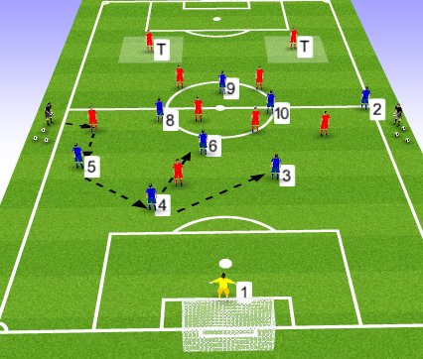 | Explanation:  - 18 Players, 9 (1GK) v 7 +2 T  - Blue 1/4/3/1 #2,3,4,5,6,8,10,9  - Red 2/4/1 #3,4,6,8,7,11,9  -balls,bibs  - 2 Target grids  SP plays into opp #7/11 who plays into Blue #2/5 and then play goes live.  Blues must play into target players to score.  #3,4 or 6 must have made a pass after receiving from #2/5 in build up to scoring.  Reds have 5 seconds to score after winning back BP.
Team Task: Can we switch play using our defenders and #6 before playing forward.

Player Tasks:  #2/5 – Decide best passing option to keep BP,4/3/GK/6?  #3/4 – when our 2/5 have BP, can we receive and look to switch play?  #6 - When 2/3/4/5 have BP can we look to get on the ball?  #8/10 – Identify if #6 is marked too tightly and need to rotate. When #6 gets the ball can we offer support to him?  GK – Be in good position to receive pass and switch play.  #9 – Work opp defensive line and show to receive and linkup play when #8 and 10 has BP. | Coaches Cues:  Identify risk and reward with pass selection.  Receive on back foot, open body shape to receive.  Head check, awareness, pass selection back to DF or can turn?  Communication to rotate and ability to pull markers away from #6 area.  Good positioning in relation to ball carrier and goal.  Drop deep into spaces between opp lines and spin off shoulder of defenders.

Training Game:
Organisation Diagram:  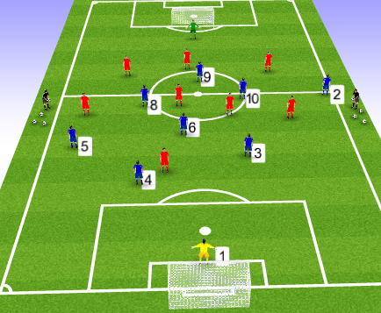 | Explanation:  - 18 Players, 9 v 9 (2GK)  - Blue 1/4/3/1 #1,2,3,4,5,6,8,10,9  - Red 1/ 3/4/1 #1,2,4,5,6,8,7,11,9  -balls,bibs  Normal game rules apply.  Look to identify understanding of;  - when to switch play  - how they switch play  - Passing and movement decisions in regards to opposition and ball position.
Evaluation: Passing practice need to keep set passing sequence as free play development meant some players getting more touches than other. In Game Training and Training game, coached team numbers could be more position specific, for example #7and 11 could be included. Having the 3 centre midfielders worked well but perhaps better to had natural width as an option for 2/5 to play into. Adjusting the practice from 18 players to 20 would help with this.

FFA Session Plan
Playing Group: Royal Blues | Session No: |  | 18 | Date: | 6th June 2017
Main Moment: | BPO
Football Problem: When opposition #7,9,10,11 are dribbling towards our goal in our D1/3, our defensive line is dropping too deep with no pressure on the ball carrier, allowing opposition to get into dangerous goal scoring areas.
Objective: In this session I aim to improve the defensive unit’s ability to defend when organised, dribbling and RWB threats breaking from M1/3 to our D1/3.
Warm up / Passing Practice
Diagram:  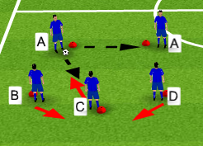  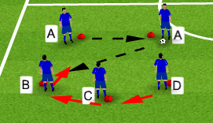 |  | Organisation/Explanation:  - 20 players, 2 grids x 5  - 5 cones per grid  - balls  As are the ball players and B,C,D are in place as ball playing defenders.  A can pass to each other at any time but no more than 2 passes in a row.  B,C,D must move out of defensive line to meet the pass and return.  If pass to B, C moves left to cover and D moves across to cover C.  Likewise if D receives a pass.  If C receives then B and D drop and get compact behind.  On coach instruction, players rotate clockwise.  Start two touch with static and dynamic stretching.  Move on to 1 touch when able.

Positioning Game:
Diagram:  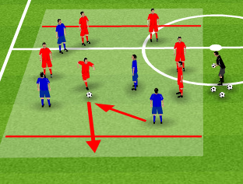 | Organisation/Explanation:  -20 players, 2 grids of 6x4  - balls, bibs  - grid with target zone at each end  6 attackers must create opportunity for a player to dribble or rwb into an end zone for a point.  Defending team can score a point by winning BP and completing 3 passes.  Make play directional. If defenders sit back and not push to win back BP, make their points double if they win back BP within 10 seconds.
Team Task: Can we break compactness to deny opposition dribbling threats?
Player Tasks:  Can player closest position to ball press the ball carrier to deny space and time?  Defender away from ball carrier to adjust positions to cover and mark, as gone through in passing practice. | Coaches Cues:  Decision of when to leave position and press  Body shape side on and low ready to tackle or turn, show ball player a direction  Covering players body shape to cover but offer balance distance between covering and marking

Game Training:
Organisation Diagram:  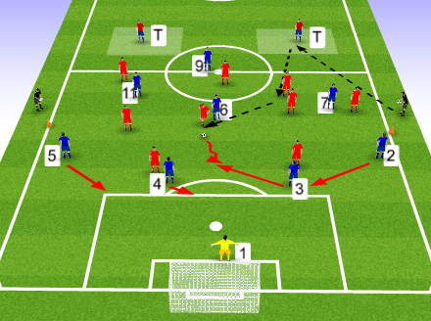 | Explanation:  - 20 players, 9 (1GK) v 9 + 2T  - Blue 1/4/3/1 #1,2,3,4,5,6,7,11,9  - Red 3/4/2 #2,3,5,6,8,7,11,9,10  SP – Play into T player who then finds an attacker. If target player has ball from receiving a pass from Blues, they can restart from there.  Red team can use target players to keep BP, and must attempt to attack with a dribble or RWB once passed the coned line.  Red team score in the goal.  Blue team must get the ball into a T player to score a point. Once T player has it they can restart straight away.
Team Task: Can we deny opposition running with the ball into our D1/3 and creating dangerous attacking opportunities?

Player Tasks:  #2,3,4,5 – Deny ball carrier space and time when rwb from M1/3?  #2,3,4,5 – When a defender steps out can we cover is position and keep compactness?  #11,7 –Make our midfield compact and support our #6  #6 – Deny opposition ball player time and space and anticipate opposition players moving to receive.  #9 –find a position so when you receive, the pass will break lines  GK – can you keep ideal positioning to sweep behind defence? | Coaches Cues:  - Step out to ball carrier and decide, delay or tackle? Body shape, show ball player a direction  - get narrow for compactness, cover hole and offer balance to change direction if needed. Head checking, communication.  - When opp midfield have bp Come inside and get narrow in more central position.  - Add pressure in M1/3, aggression in challenges to stop runs happening from M1/3.  - Drop in between opposition defence and MF units when in BPO.

Training Game:
Organisation Diagram:  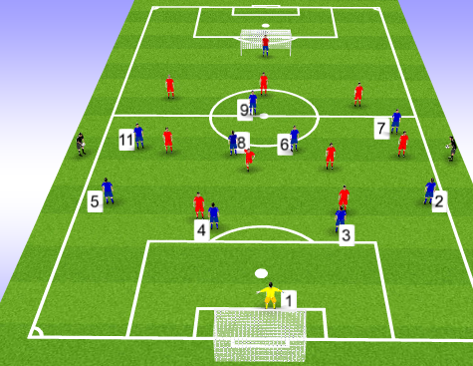 | Explanation:  - 20 players, 10v10 (2GKs)  - Blue 1/4/4/1 #1,2,3,4,5,6,7,8,11,9  - Red 1/3/4/2 #1#2,3,5,6,8,7,11,9,10  Normal football rules apply.  Look for evidence of;  Defenders compactness and pressing out to challenge opposition ball player.  Do they offer cover?  Do they offer balance?  Is midfield trying to deny the scenario from happening?
Evaluation:
Positioning game was the correct concept but poor choice of structure. Proved difficult to get defenders to commit and allow space for attacking team to start a rwb or dribble. Need to add better rules to make defenders commit into a press. Player tasks followed and worked perfectly, all defence working as a unit and covering the pressing defender who broke the unit and still keeping compactness.

FFA Session Plan
Playing Group: Royal Blues FC | Session No: |  | 19 | Date: | 10th May 2017
Main Moment: | BPO-BP
Football Problem: When our GK has opportunity to set counter attacks with a throw or kick, players are still in defensive positions within our A1/3 and M1/3, meaning GK must wait for better options and allows opposition to reset their defensive shape.
Objective: In this session I aim to improve our counter attacking capabilities when GK receives ball from opposition attack in our D1/3.
Warm up / Passing Practice
Diagram:  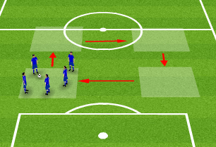 |  | Organisation/Explanation:  - 20 Players, 4 grids x 5 players per grid  - 4 grids equal distance apart  - 4 balls, 1 per grid  1. Players have 2 touches, pass and move into location of pass. Dynamic and static stretch.  2. 1 touch passing and on coaches cue, players move into the next grid (clockwise) leaving the ball where it is.  3. Pass and move, on coaches cue move to next grid and take ball with you by dribble or pass.  ** grid movement 1 whistle clockwise, 2 whistles anti-clockwise.  4. After making two passes, player can move into any grid they choose.

Positioning Game:
Diagram:  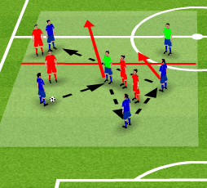 | Organisation/Explanation:  - 20 Players, 2 grids x 10  - bibs and balls  - 2 grids with centre line across the middle  - 4v4+2N  To score, a team must make 3 passes in one half and then transfer into the other half and complete 3 passes (the transfer pass does NOT count).  N players can be used for both teams.  Development – N players are now target players who must receive at the end of the pass sequence to score the point.  Play first to amount of points or 4 rounds of 2 minutes.
Team Task: Can we move into good receiving positions after passes are made and break forward with off ball runs?
Player Tasks:  Ball player – can you make short pass and move into ideal position to receive as 3rd man/or even into opposite half?  Secondary players – Can you make short quick pass combinations to keep BP?  3rd pass player – can we build play into the opposite half with killer pass or keep BP to recycle?  Furthest ball player – can you make well timed runs into opposite half to keep BP and score a point? | Coaches Cues:  Quickness of play  Quality and weight of pass  1 touch play for change of tempo  Off ball runners for the counter into opposite half  Support play after the counter attack pass

Game Training:
Organisation Diagram:  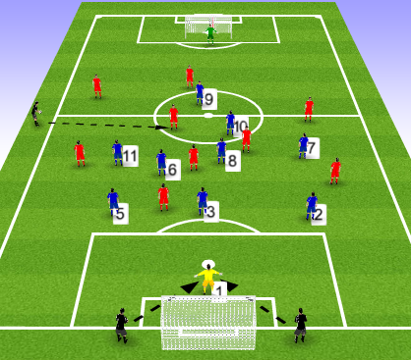 | Explanation:  - 20 players, 10v10 (2GKs)  - Blue 1/3/5/1 #1,2,3,5,6,8,7,9,0,11  - Red 1/3/2/3/1 #1,2,3,5,6,7,8,9,10,11  Sp – Starts with ball into opposition midfield to attack or coach either side of the GK for quick start.  Teams must score in the goal.  Opp has 5 seconds to score before play restarts with GK.  Opp must have at least 7 players in their attacking half (past halfway line) to score, thus setting up the counter attack situation.
Team Task: When our GK has BP, can we move into positions to help set up quick counter attacks?

Player Tasks:  GK – When gaining BP start a counter attack as quick as possible.  #2,5 – when GK gets BP get high and wide.  #6 – when GK gets BP protect #3 and be in a position to collect and switch play.  #7,11 – When GK gets ball get high and wide into opp half.  #8, 10 – When GK gets BP decide who pushes high to support #9 and who comes to build play to support #6.  #9 – When GK gets BP be ready to run onto passes into space behind opp defence. | Coaches Cues:  Already have vision of where 1st pass will go on receiving BP.  Get higher than the Opp #9 but not the same verticle line as 7,11.  #6 – sit in front of defence and behind 8,10.  Don’t be on same verticle line as 2,5.  Confident to receive, receive on the turn.  Position yourself between opp fb and cb.

Training Game:
Organisation Diagram:  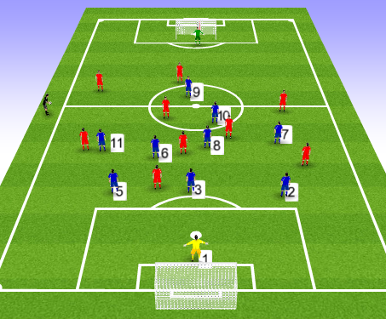 | Explanation:  - 20 players, 10v10 (2GKs)  - Blue 1/3/5/1 #1,2,3,5,6,8,7,9,0,11  - Red 1/3/2/3/1 #1,2,3,5,6,7,8,9,10,11  Normal rules apply.  Check for understanding of;  - GK tempo on winning BP and decision making  - Positioning of players on GK getting BP
Evaluation: Whole session structure complimented each part and from the start, got players switched on to think about movement for the counter attack. At the same time, GK’s has specific training on distribution with the GK coach. Fortunately, there was enough turnovers in BP during GT and TG to allow for the objective to be practiced. Getting opp players to commit to attack in the GT allowed the coached team to counter attack which was realistic to the main objective.

FFA Session Plan
Playing Group: | Session No: 20 |  |  | Date:
Main Moment: | BP
Football Problem: Our #7 & 11 are losing 1v1 battles against opposition #7 & 11 in wide areas of M1/3, resulting in play being slowed down with backward passes into our D1/3.
Objective: In this session I aim to improve our ability to create overloads in wide areas against opposition #7, 11 and continue to play forward into A1/3.
Warm up / Passing Practice
Diagram: |  | Organisation/Explanation:

Positioning Game:
Diagram: | Organisation/Explanation:
Team Task:
Player Tasks: | Coaches Cues:

Game Training:
Organisation Diagram: | Explanation:
Team Task:

Player Tasks: | Coaches Cues:

Training Game:
Organisation Diagram: | Explanation:
Evaluation:

